**AWS CloudWatch**

* CloudWatch monitors your AWS resources and the applications you run on AWS in real time.
* It is used to collect and track metrics. Here you can create dashboards, alarms, etc.
* **How CloudWatch works**

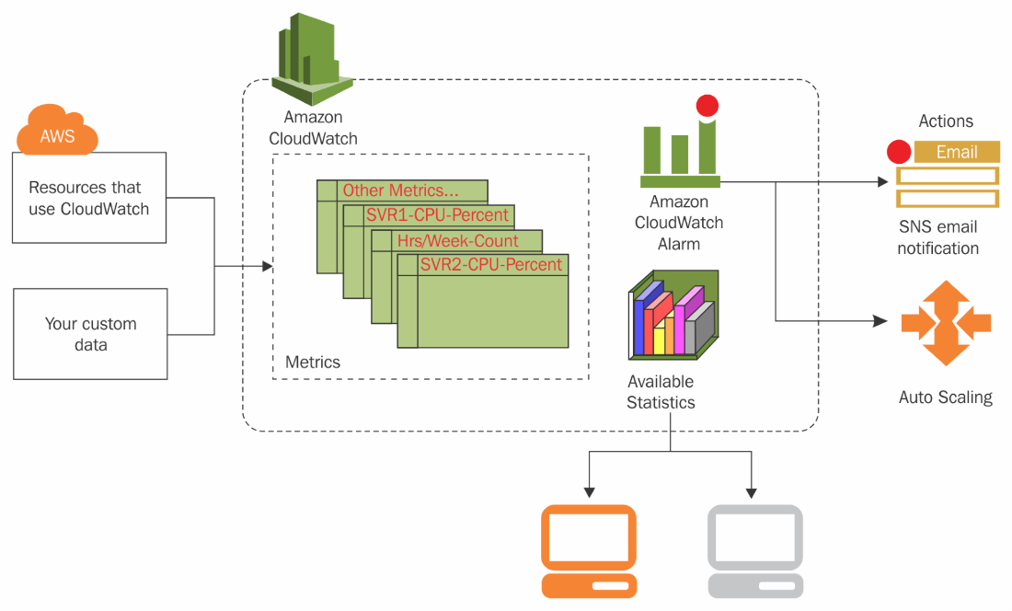

* **Basic Concepts**

1. Namespaces: A namespace is a container for CloudWatch metrics. Metrics in different namespaces are isolated from each other, so that metrics from different applications are not mistakenly aggregated into the same statistics.
2. Metrics: A metric represents a time-ordered set of data points that are published to CloudWatch. Metrics are uniquely defined by a name, a namespace, and zero or more dimensions.
3. Dimensions: A dimension is a name/value pair that is part of the identity of a metric.
4. Statistics: Statistics are metric data aggregations over specified periods of time.
5. Percentiles: A percentile indicates the relative standing of a value in a dataset.
6. Alarms: An alarm watches a single metric over a specified time period, and performs one or more specified actions, based on the value of the metric relative to a threshold over time.
7. Aggregation: Amazon CloudWatch aggregates statistics according to the period length that you specify when retrieving statistics.
8. Periods: A period is the length of time associated with a specific Amazon CloudWatch statistic.

**Using Amazon CloudWatch Dashboards**

* To access CloudWatch dashboards, you need one of the following:

1. The AdministratorAccess policy
2. The CloudWatchFullAccess policy
3. A custom policy that includes one or more of these specific permissions

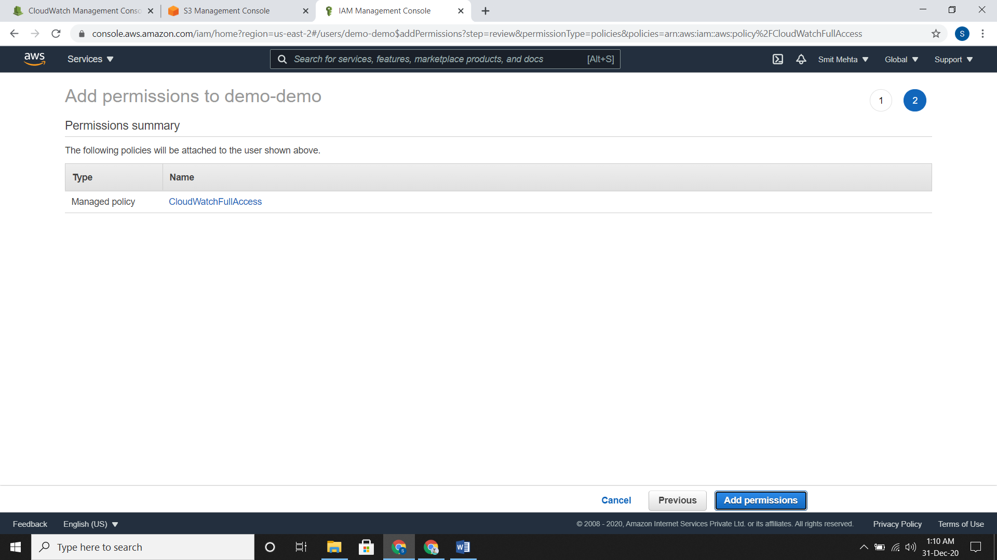

**Creating a Dashboard**

* Go to dashboard, click on create dashboard and give it a name
* Now select a widget type to configure. You can add many widgets for the same dashboard.
* After selecting any widget, you need to select the data source from which you need to create.

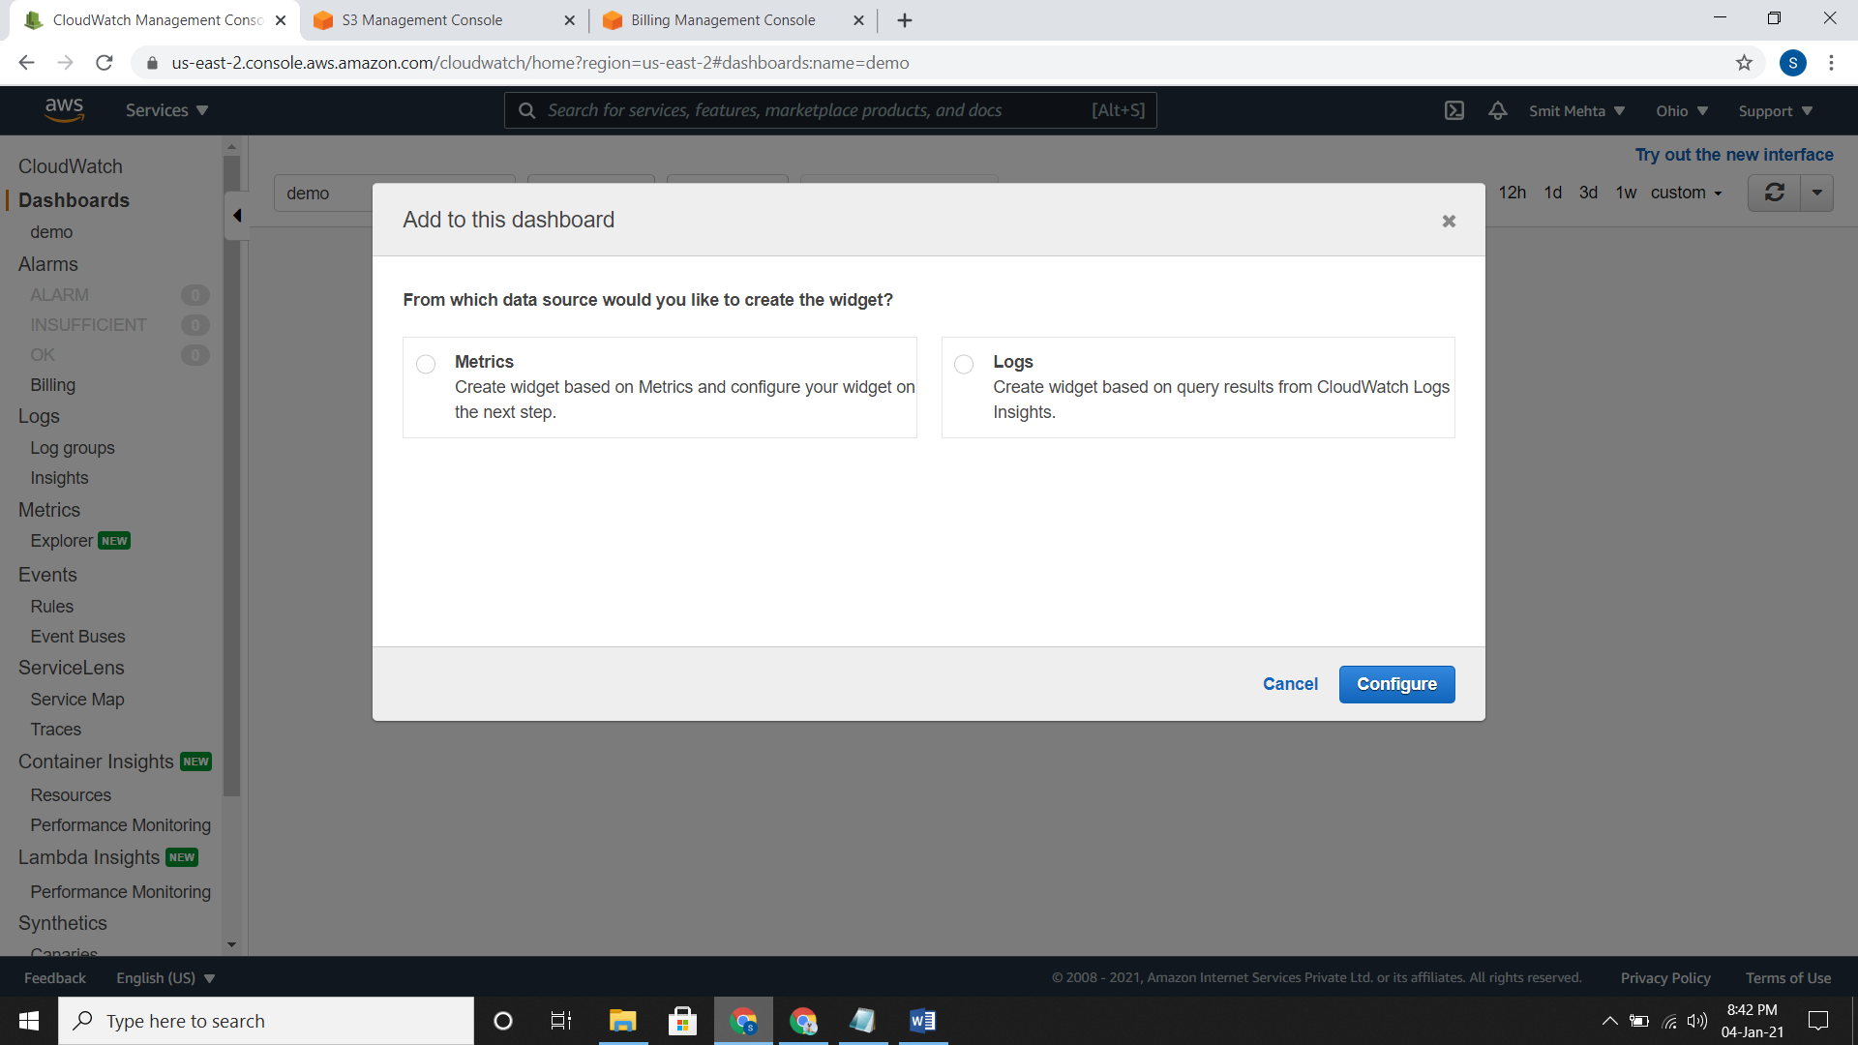

* From the action button you can create, save, share, delete a dashboard and can do many more things.

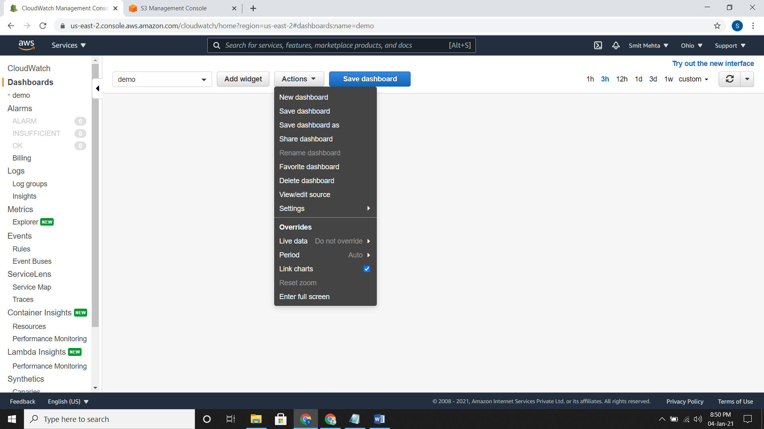

**ALARM**

**Setting up a SNS Topic and subscribing it**

* **Using AWS Console**
* Go to the SNS dashboard and create a topic. Here, choose the required **type** i.e. for email, HTTP, SMS and all choose type as standard.
* Now click on create subscription and choose the required protocol. Here you need to confirm your mail-id or number or required thing which you have provided, till the status is changes to confirmed from pending.

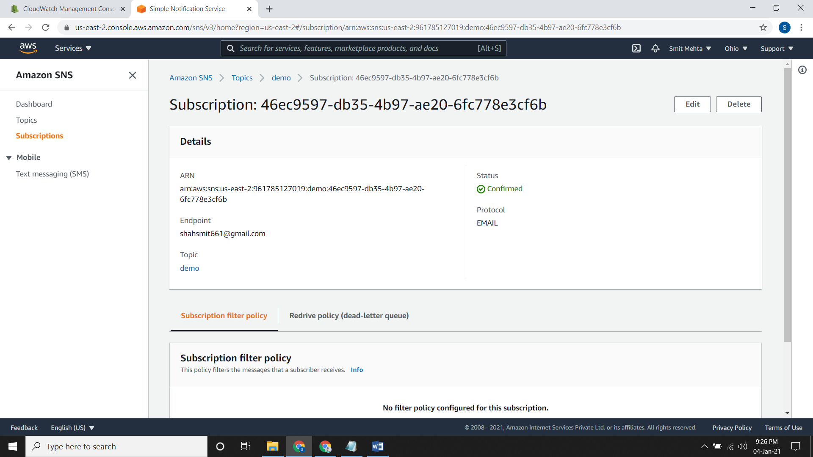

* **Using AWS CLI**
* Following commands are used to create topic and to subscribe to it using email.

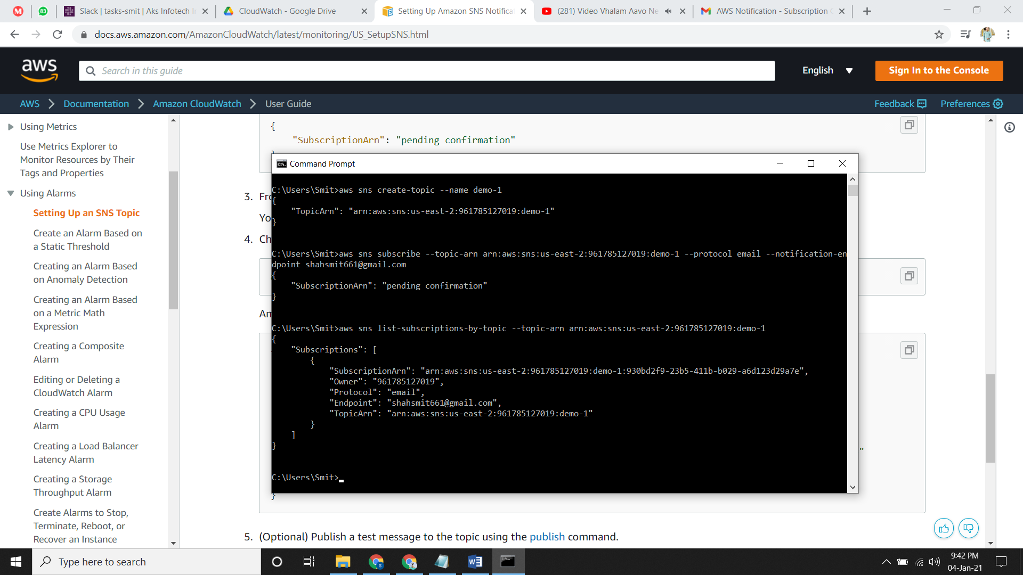

**Creating a CPU Usage Alarm That Sends Email**

1. **In AWS CONSOLE:**

* You should have instances running and a SNS topic with subscription.
* Now go to Alarm, create it and select the Metric
* Go to AWS Namespaces, then to EC2 > Per instance metric and in the checkbox type **CPUUtilization.**

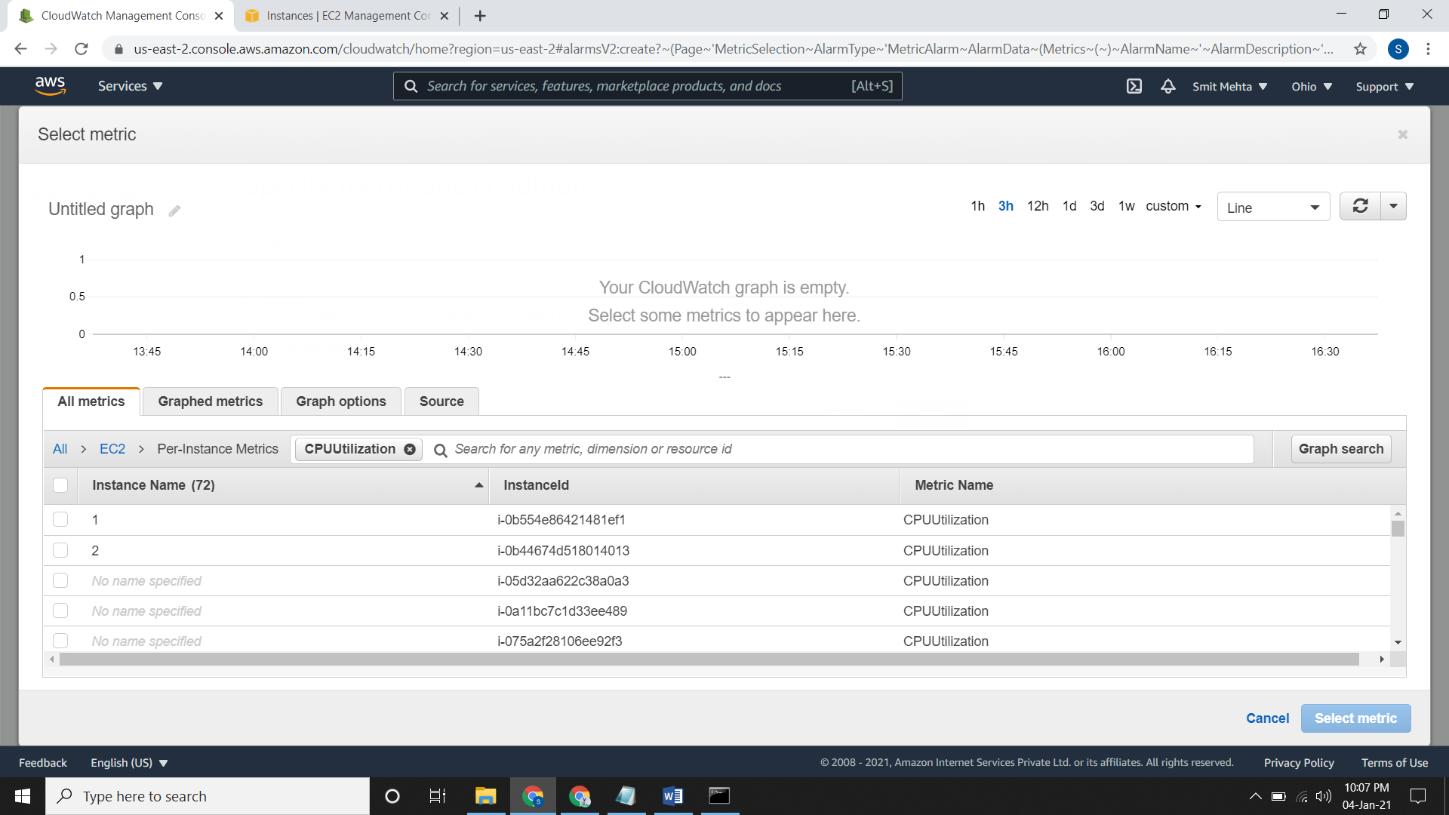

* Now select the instance and click on **Select Metric**. Now give your requirement according to you. I’ll give if threshold value is less than 25%.
* After clicking on Next give select the SNS topic for alarm state and then give name and description for alarm. Preview it and create it.

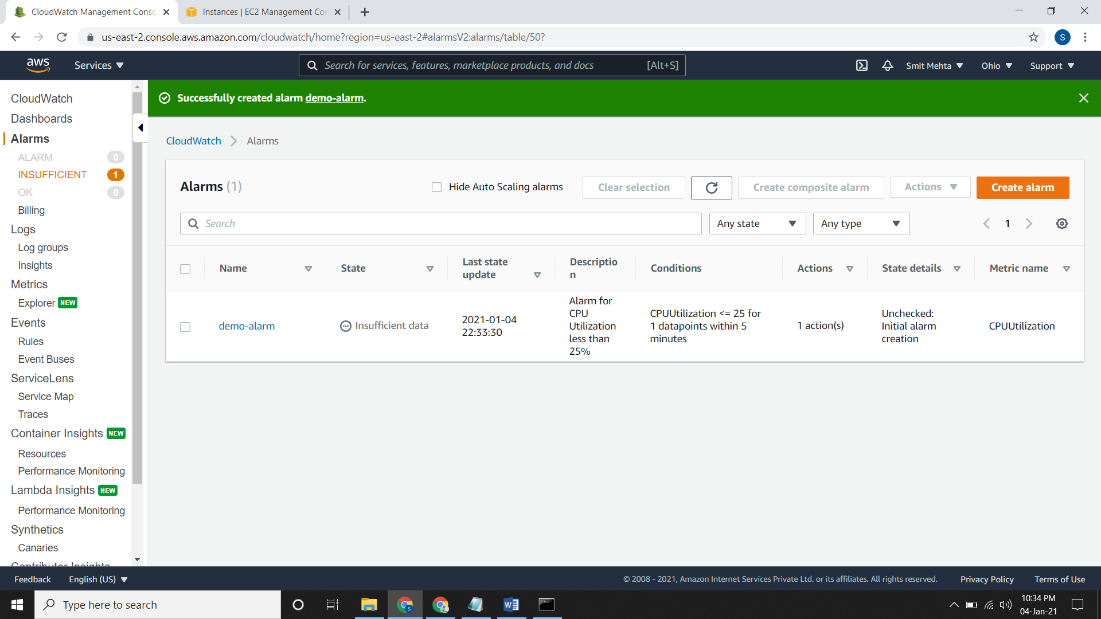

* Now my alarm sets up and gives me notification as the CPU Utilization goes below 25%

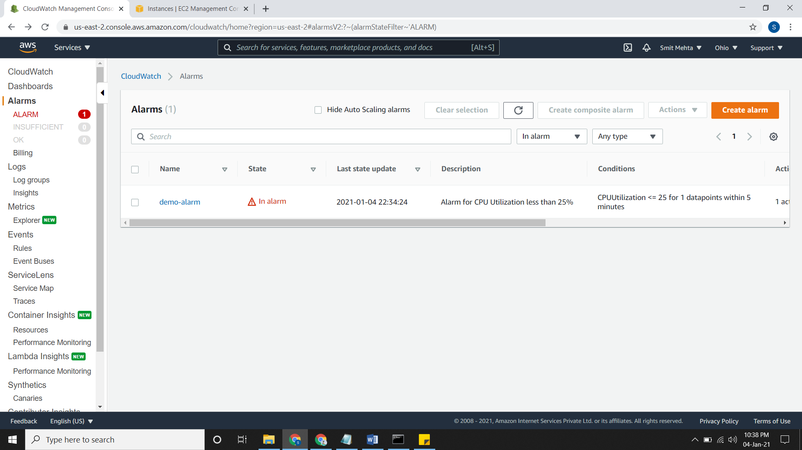

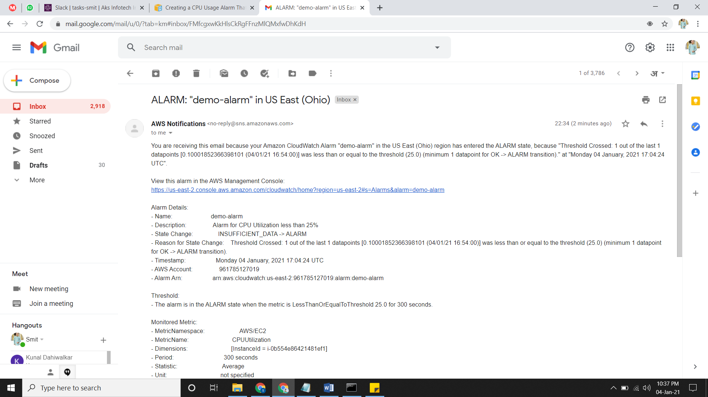

1. **Using AWS CLI:**

* The following command is used to create an alarm for threshold greater than 70% for CPU Utilization.

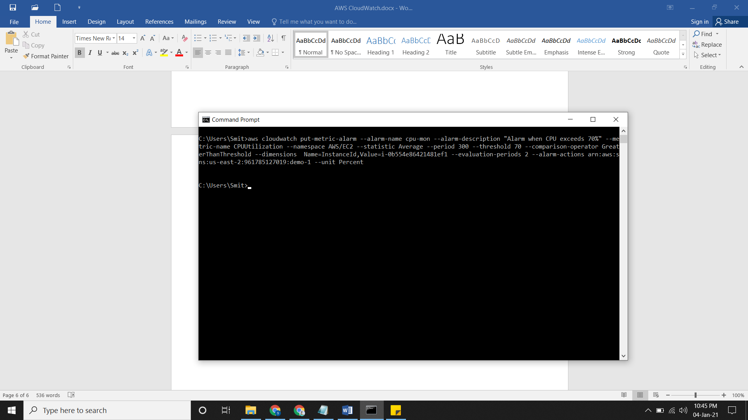

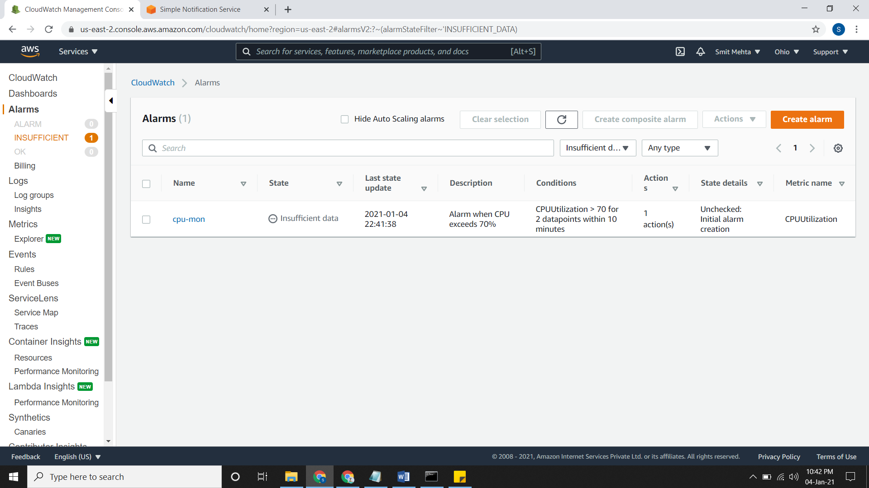

* Change the alarm state from INSUFFICIENT_DATA to OK and from OK to ALARM

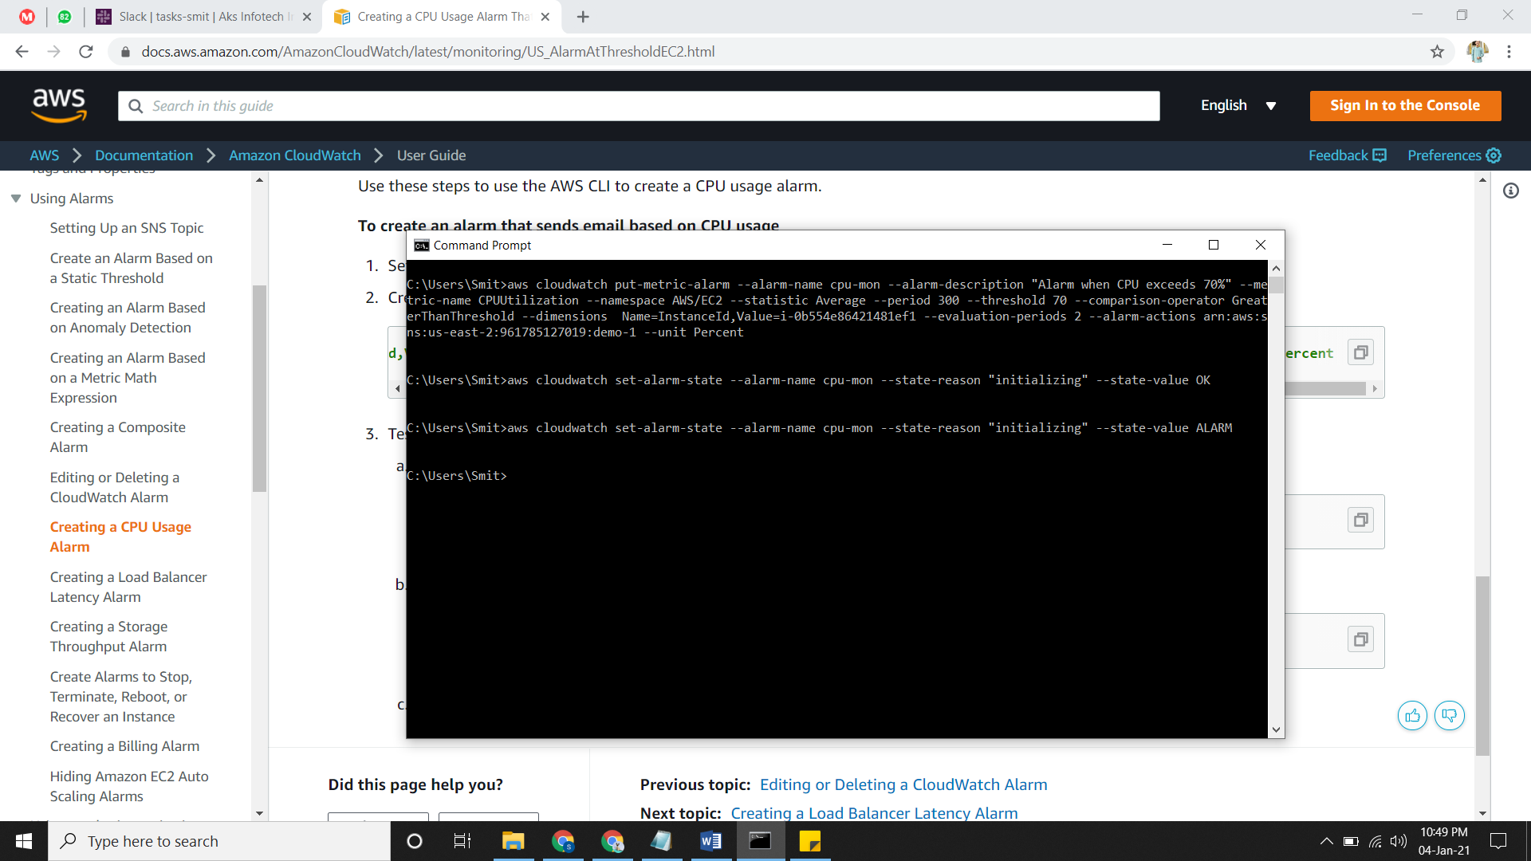

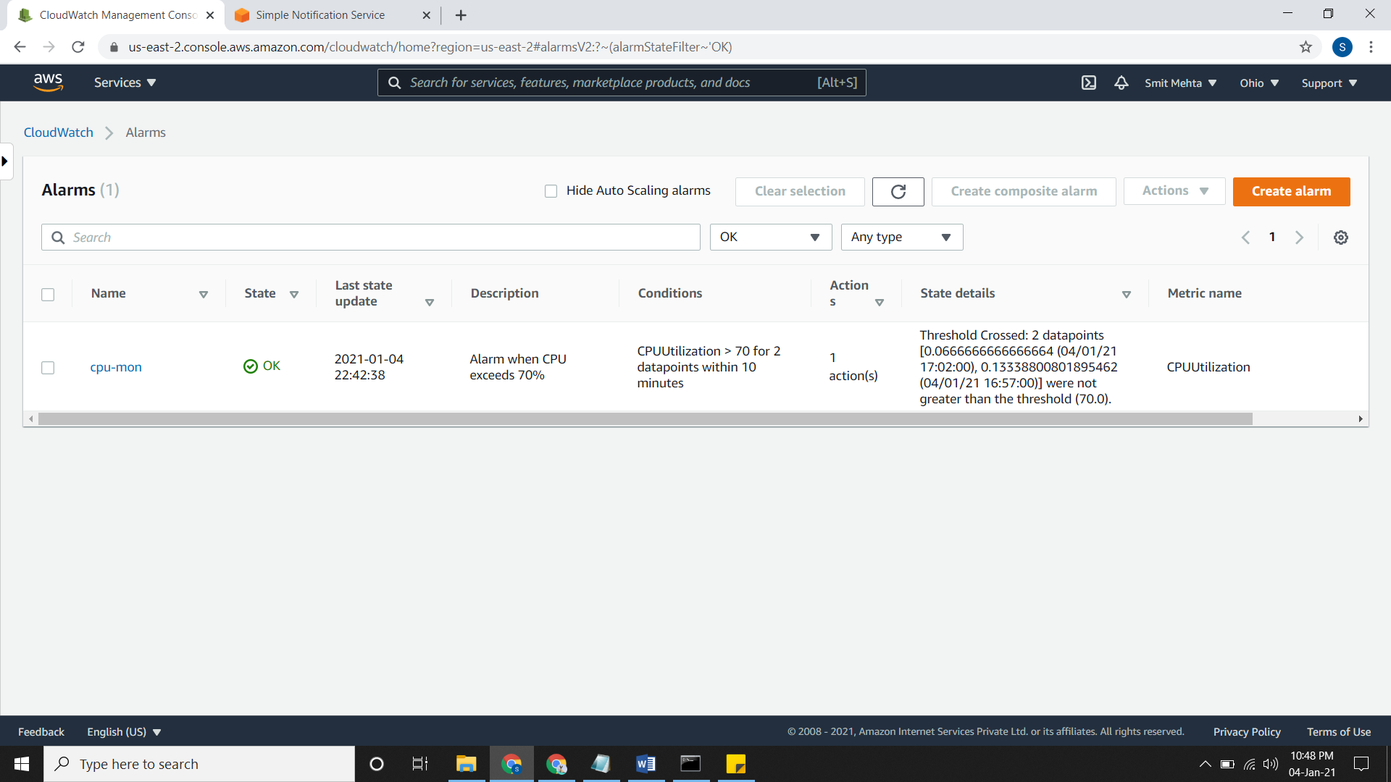

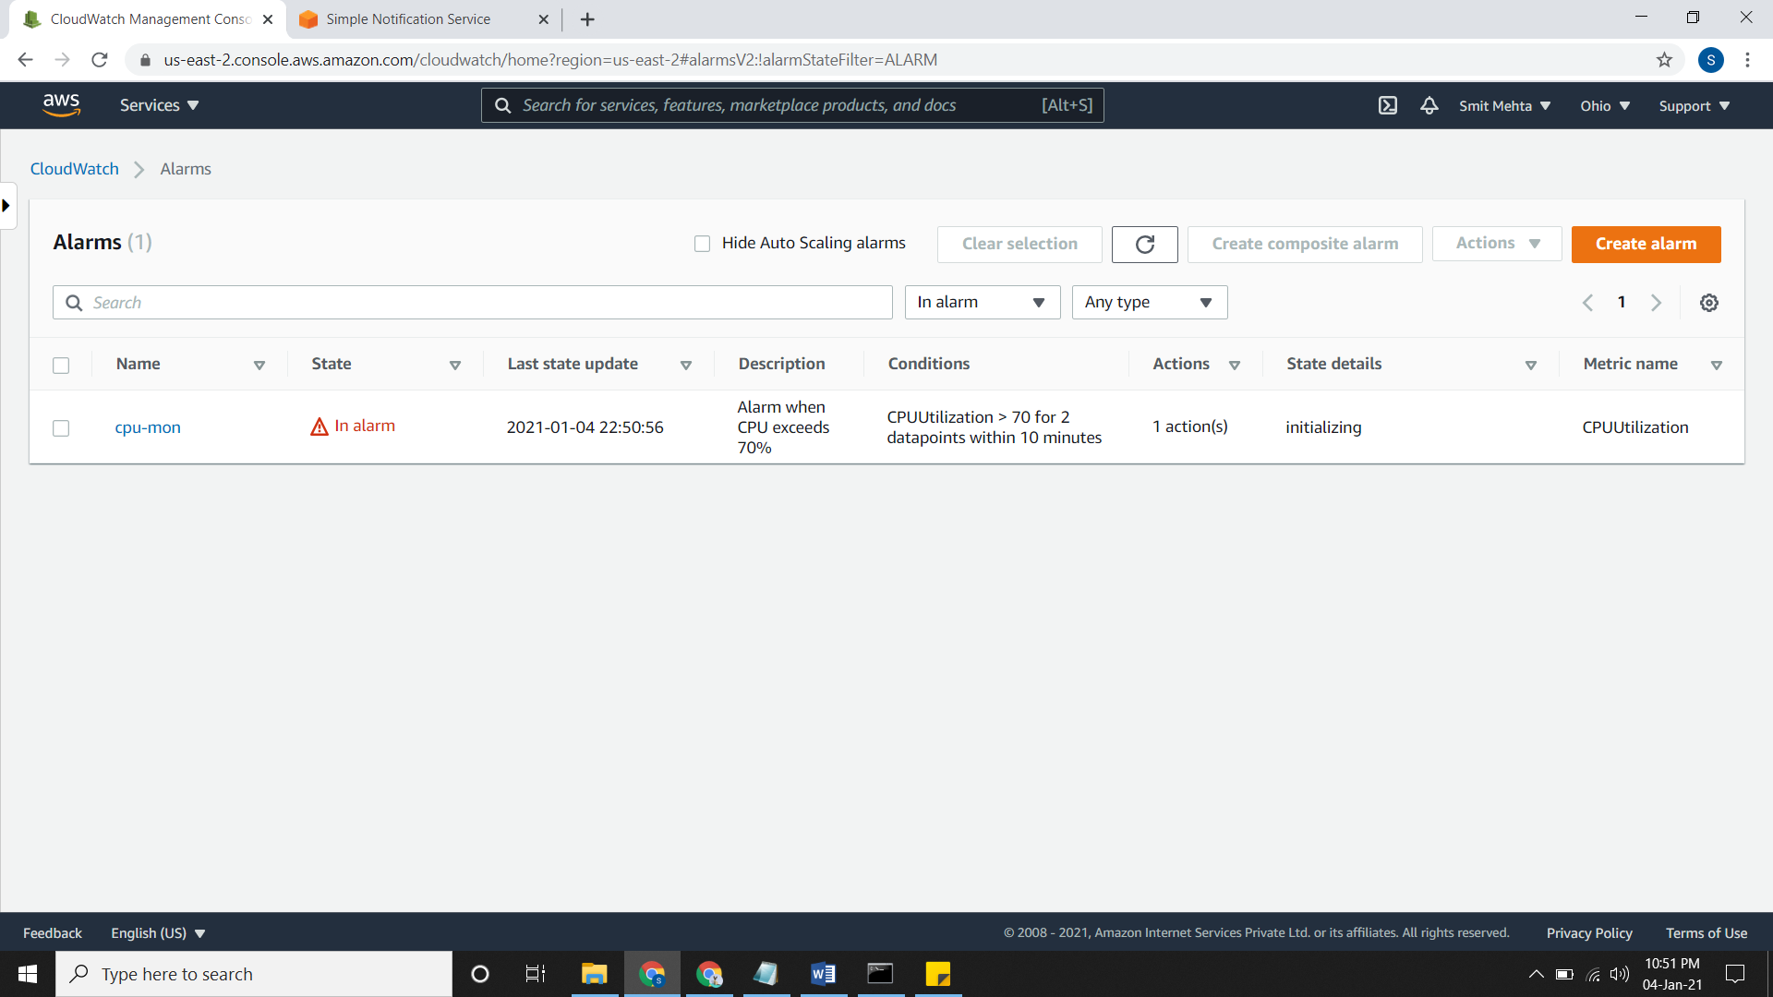

**Create a CloudWatch Alarm Based on a Static Threshold**

* Now go to Alarm, create it and select the Metric
* Go to AWS Namespaces, then to EC2 > Per instance metric and in the checkbox type **CPUUtilization.**
* Select the instance and click on Graphed Metric. Now choose the statistic and period accordingly and click on select metric.
* Now give your requirement according to you but threshold type should be **Static**.
* After clicking on Next give select the SNS topic for alarm state and then give name and description for alarm. Preview it and create it.

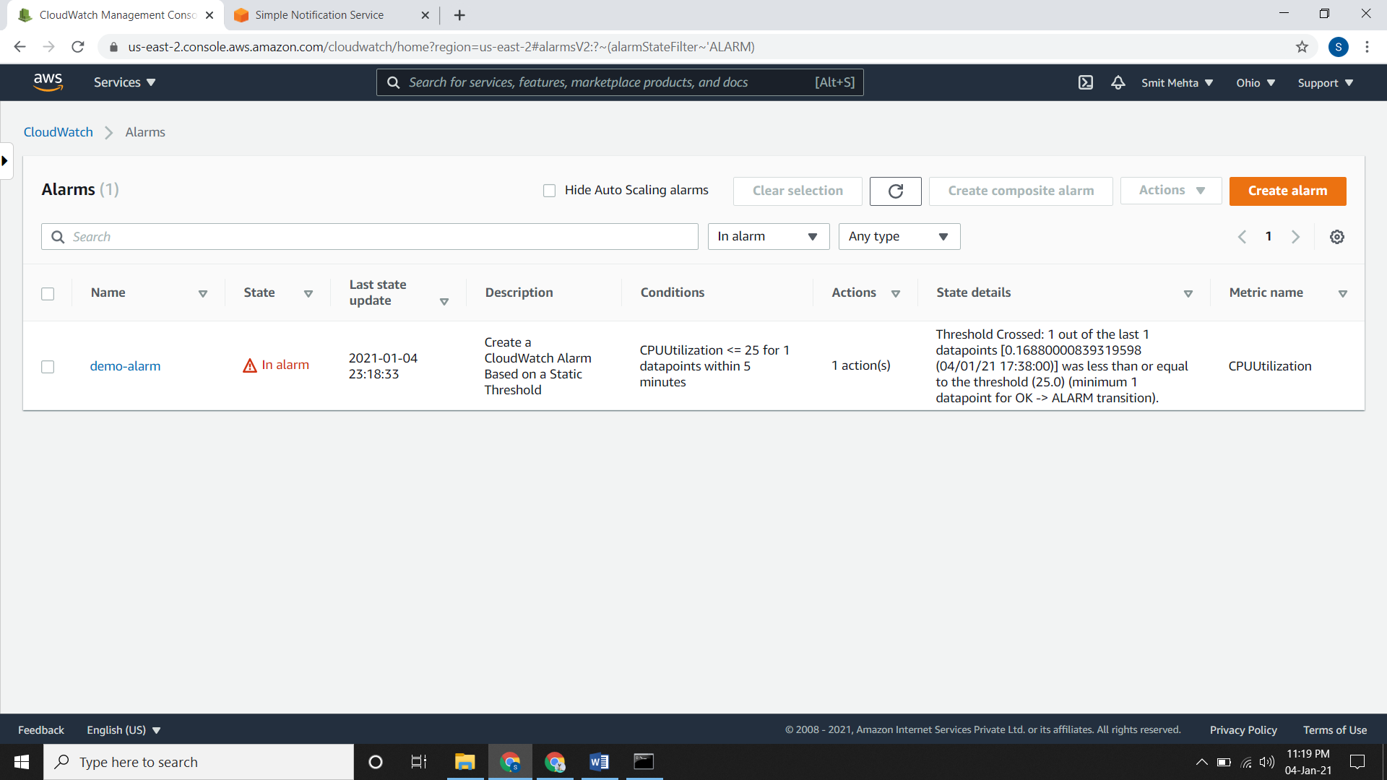

**Creating a CloudWatch Alarm Based on Anomaly Detection**

* Now go to Alarm, create it and select the Metric
* Go to AWS Namespaces, then to EC2 > Per instance metric and in the checkbox type **CPUUtilization.**
* Select the instance and click on Graphed Metric. Now choose the statistic and period accordingly and click on select metric.
* Now give your requirement according to you but threshold type should be **Anomaly**.
* After clicking on Next give select the SNS topic for alarm state and then give name and description for alarm. Preview it and create it.

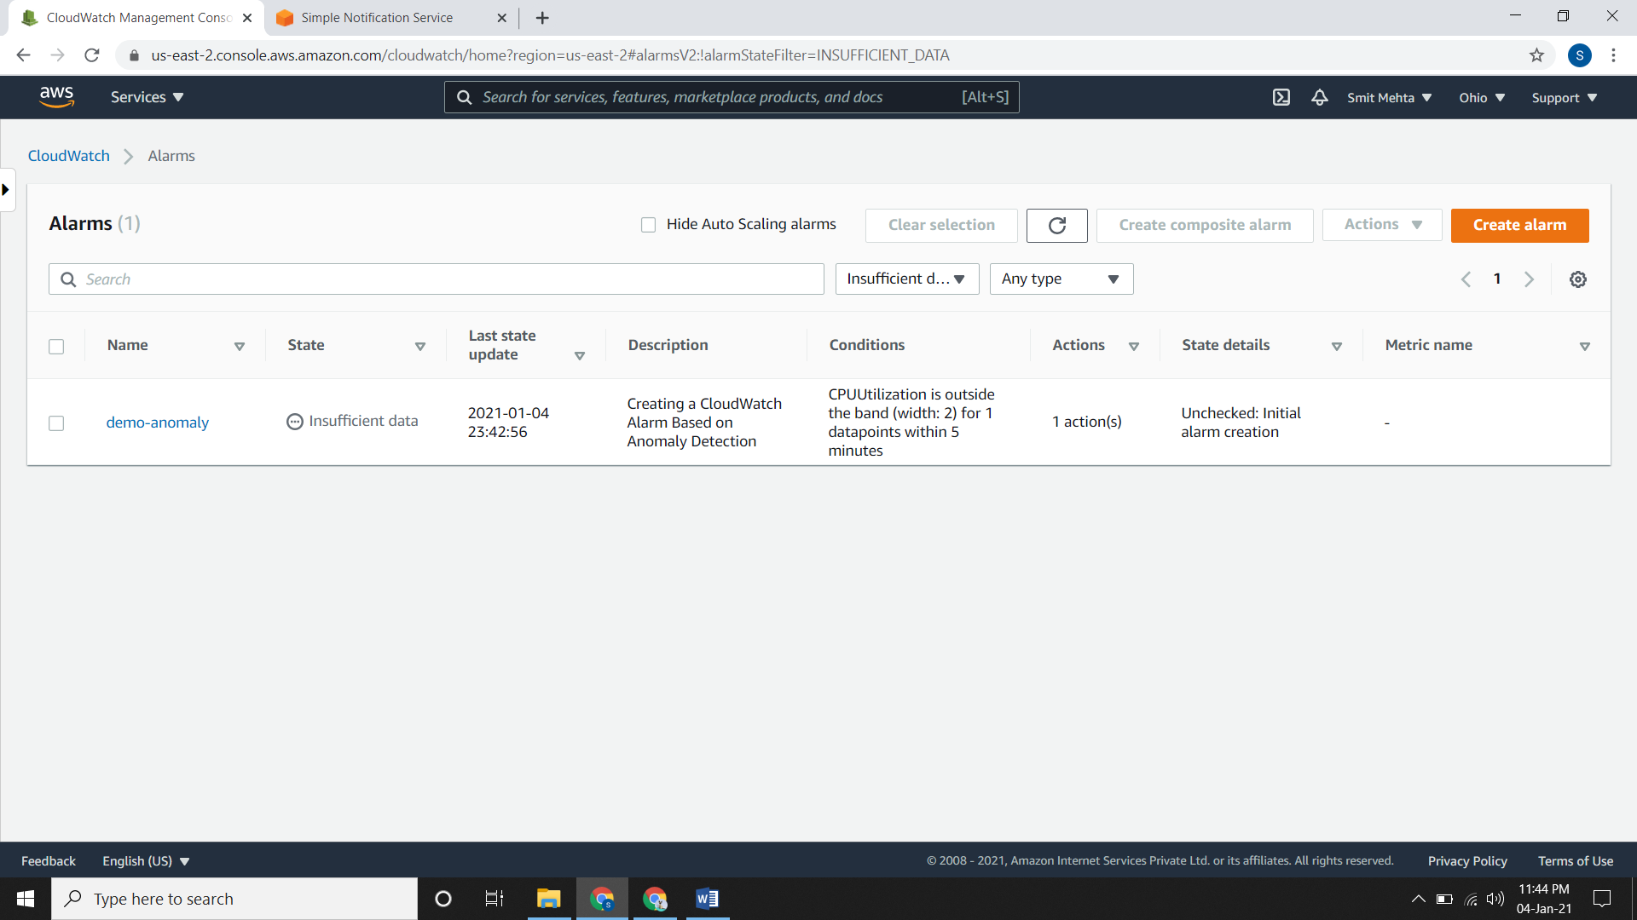

**Modifying an Anomaly Detection Model**

* Go to Alarm, select the **View in Metric,** in lower side of page click on **Edit Model**
* Now click on the **Add another time range to exclude from training** and add the time range **&** select the **metric Timezone.**

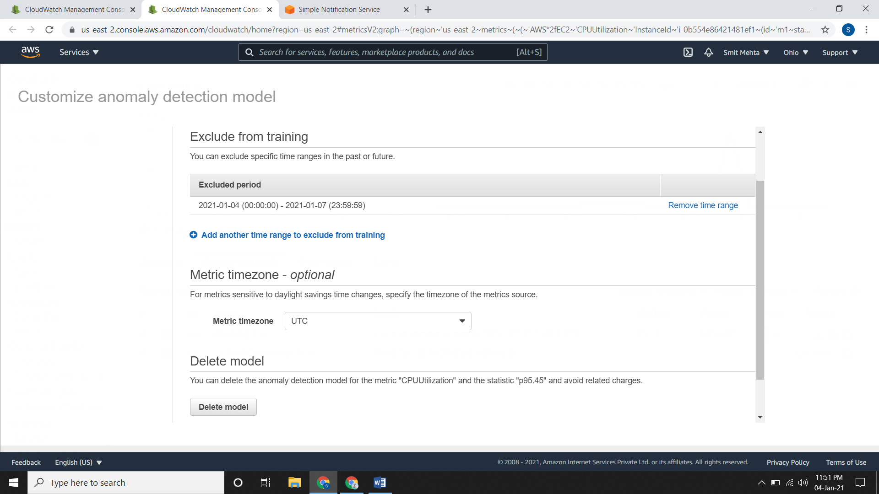

**Deleting an Anomaly Detection Model**

* Select the Alarm and click on actions and then delete it.

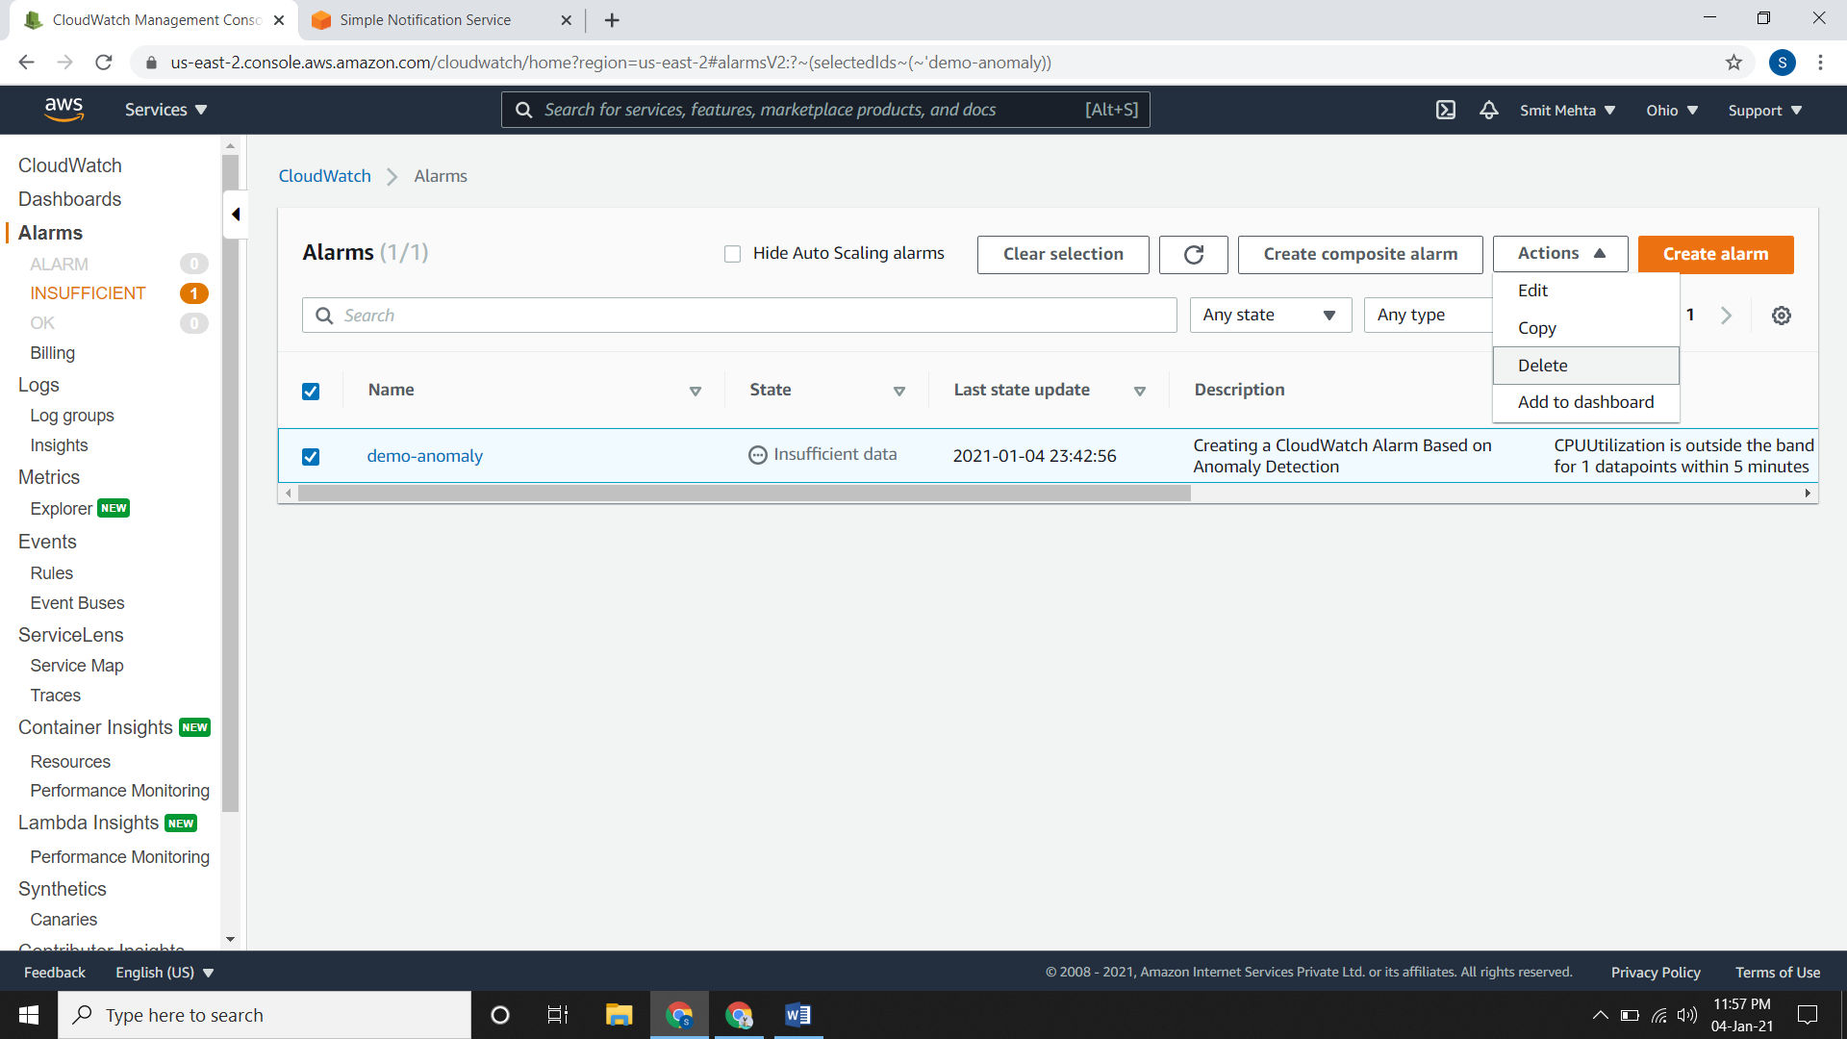

**Creating a CloudWatch Alarm Based on a Metric Math Expression**

* Now go to Alarm, create it and select the Metric
* Go to AWS Namespaces, then to EC2 > Per instance metric and in the checkbox type **CPUUtilization.**
* Select the instance and click on Graphed Metric. Now choose the statistic and period accordingly and click on select metric.
* Now give your requirement according to you but threshold type should be **Anomaly**.
* After clicking on Next give select the SNS topic for alarm state and then give name and description for alarm. Preview it and create it.

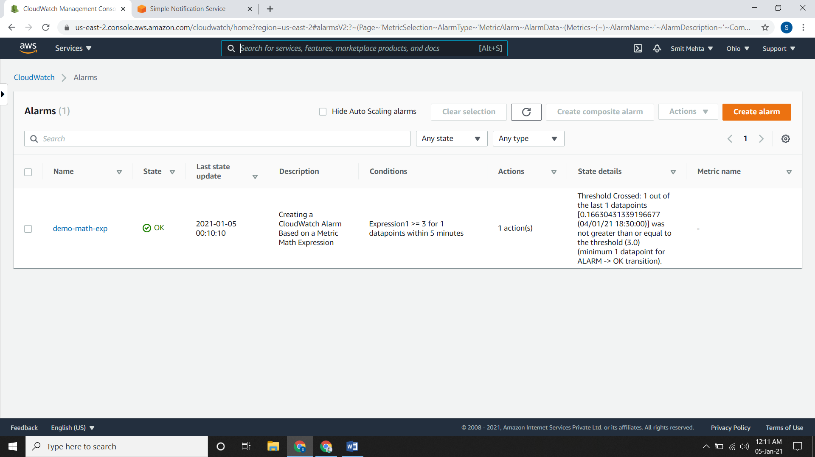

**Creating a Composite Alarm**

* Now go to Alarm, select any alarm and click on **create composite alarm.**
* In the **Conditions** box, specify the rule expression that the composite alarm will use. For ex. you could specify the following conditions to create a composite alarm that goes into ALARM state if CPUUtilizationTooHigh OR DiskReadOpsTooHigh is in ALARM state, at the same time that NetworkOutTooHigh is in OK state.
* After clicking on Next give select the SNS topic for alarm state and then give name and description for alarm. Preview it and create it.

**Creating a Load Balancer Latency Alarm That Sends Email**

* By using AWS CLI the command used is

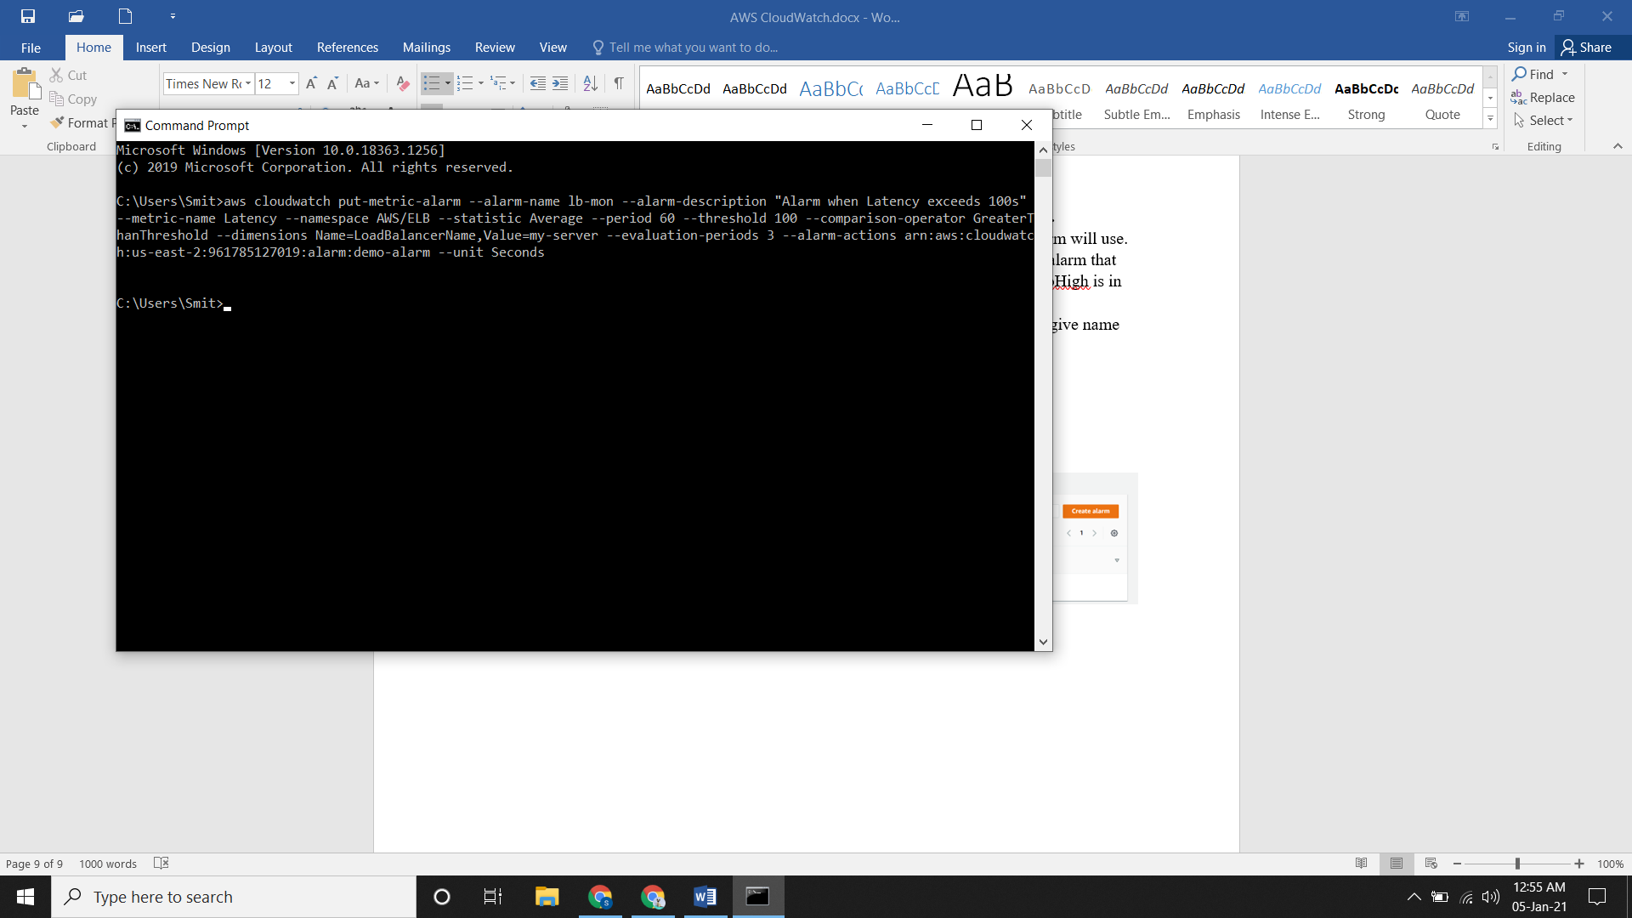

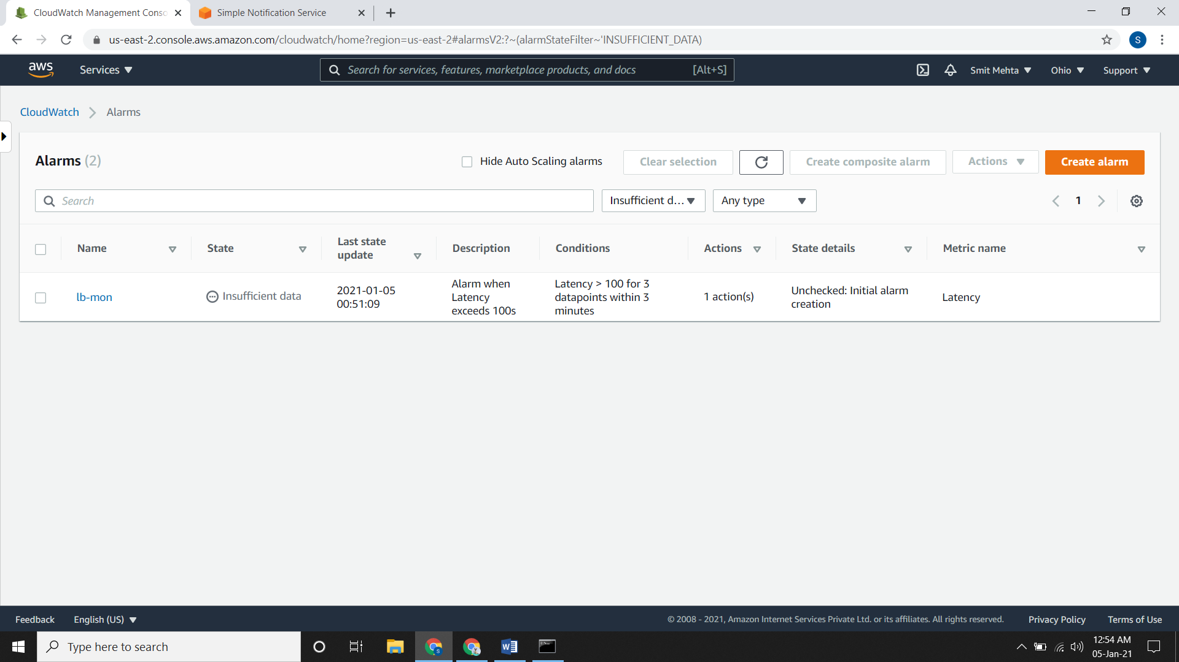

**Creating a Storage Throughput Alarm that Sends Email**

* Now go to Alarm, create it and select the Metric
* Go to AWS Namespaces, then to **EBS** > **Per Volume Metric** and in the checkbox type **VolumeWriteBytes**
* Select the instance and click on Graphed Metric. Now choose the statistic and period accordingly and click on select metric.
* Now give your requirement according to you but threshold type should be Static.
* After clicking on Next give select the SNS topic for alarm state scroll down and open the EC2 action. Go select which you want and then give name and description for alarm. Preview it and create it.

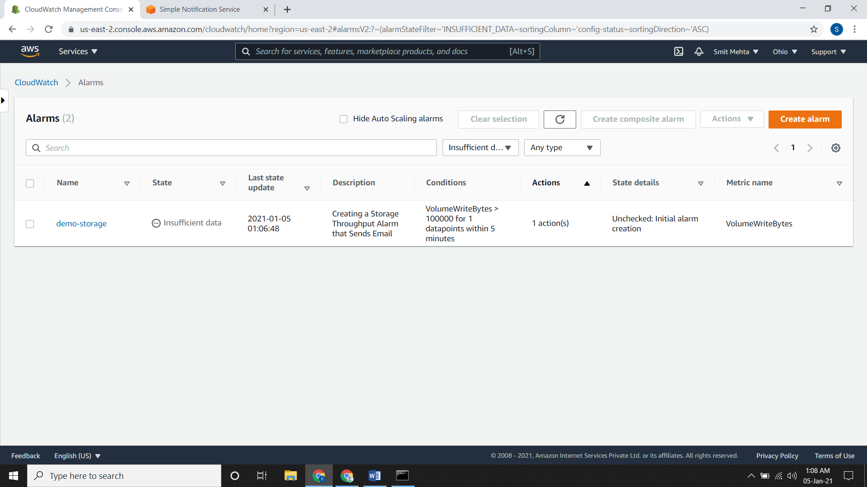

**Create Alarms to Stop, Terminate, Reboot, or Recover an Instance**

* Now go to Alarm, create it and select the Metric
* Go to AWS Namespaces, then to EC2 > Per instance metric and in the checkbox type **CPUUtilization**
* Select the instance and click on Graphed Metric. Now choose the statistic and period accordingly and click on select metric.
* Now give your requirement according to you but threshold type should be Static.
* After clicking on Next give select the SNS topic for alarm state scroll down and open the EC2 action. Go select which you want and then give name and description for alarm. Preview it and create it.

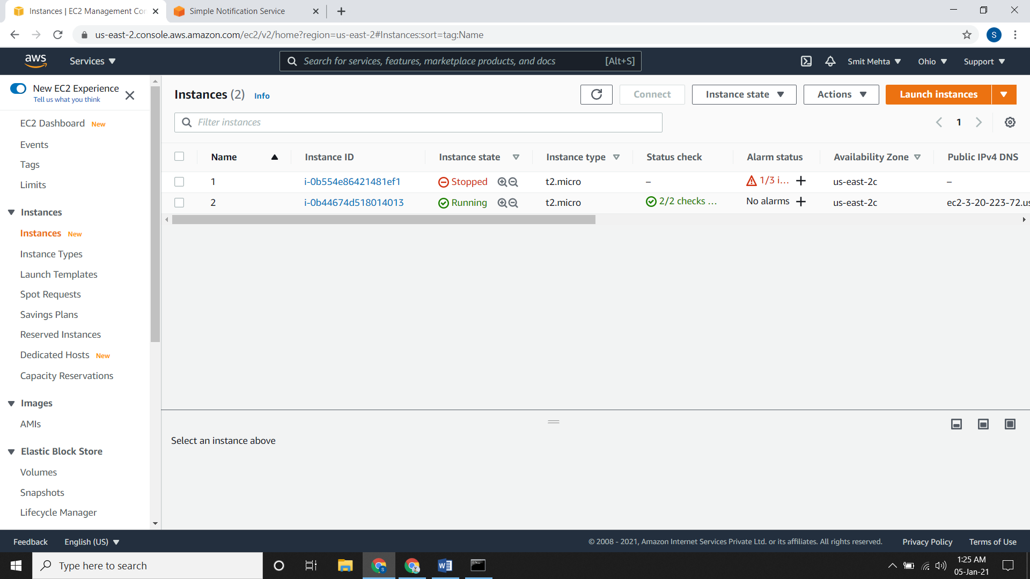

**Enable BILLING Alerts**

* Go to Billing dashboard and select **Billing Preferences.** Now select the **Receive Billing Alerts.**

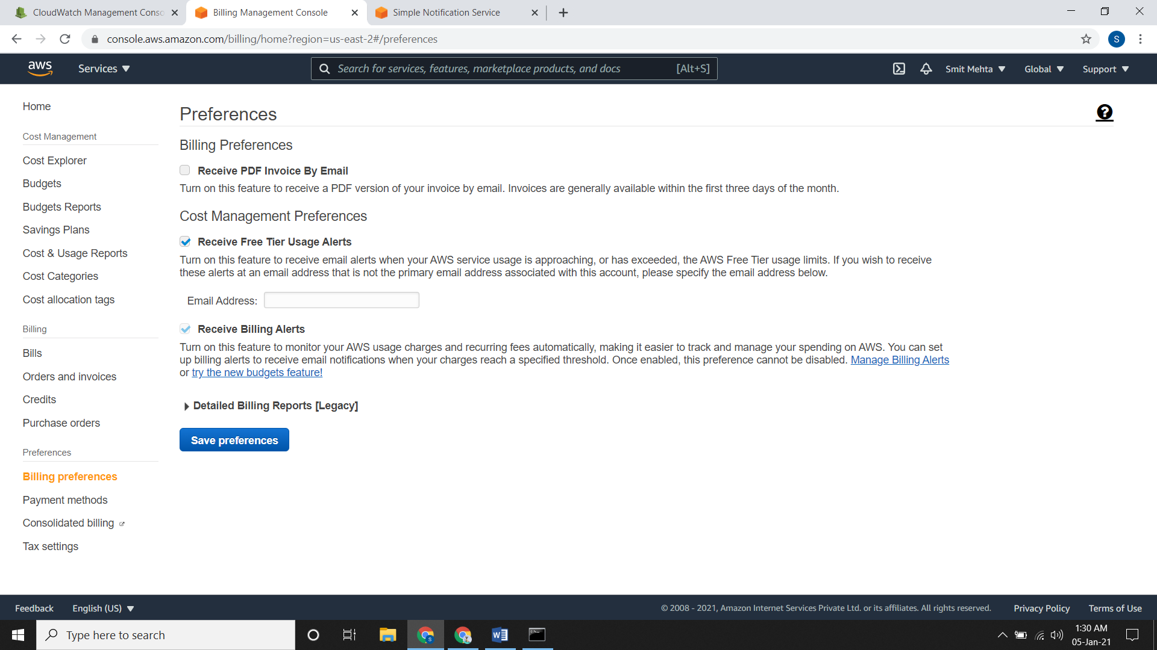

**Creating a Billing Alarm**

* Firstly, change your location to US East (N. Virginia) and then go to Alarm, create it and select the Metric
* Go to AWS Namespaces, then to Billing > Total Estimated Charge and select USD
* Select the instance and click on Graphed Metric. Now choose the statistic and period accordingly and click on select metric.
* Now give your requirement according to you but threshold type should be Static.
* After clicking on Next give select the SNS topic for alarm state scroll down and open the EC2 action. Go select which you want and then give name and description for alarm. Preview it and create it.

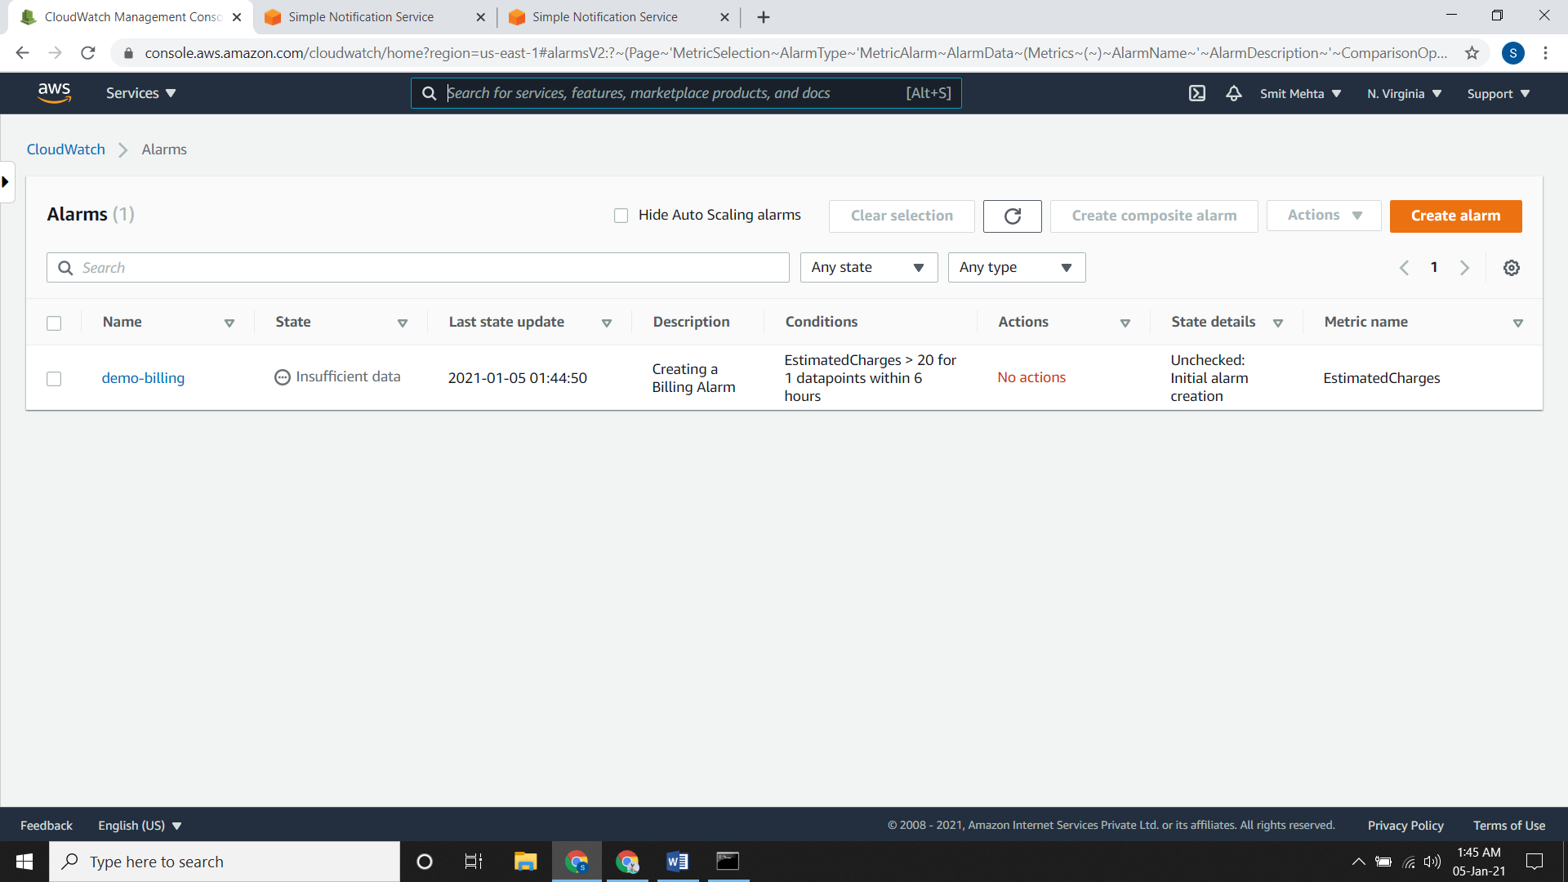

**Deleting a Billing Alarm**

* It is same you delete a normal alarm. Select the alarm, go to actions and delete it.

**METRIC**

**Viewing available metric using AWS Console**

* Go to Metric and search for your namespace like EC2, EBS, EMR, etc. Select it and go forward.

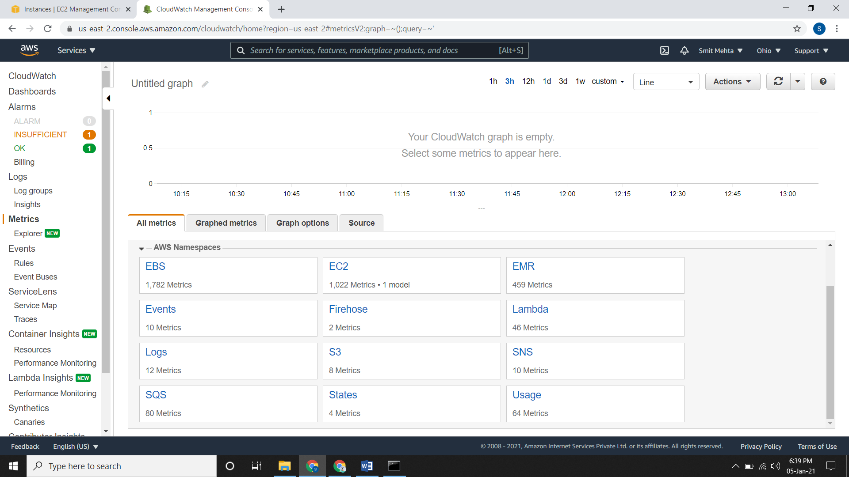

* After going forward, you will see the instance which are running and on which metric name are they. Search the name accordingly and from here you can see the graphed metric.

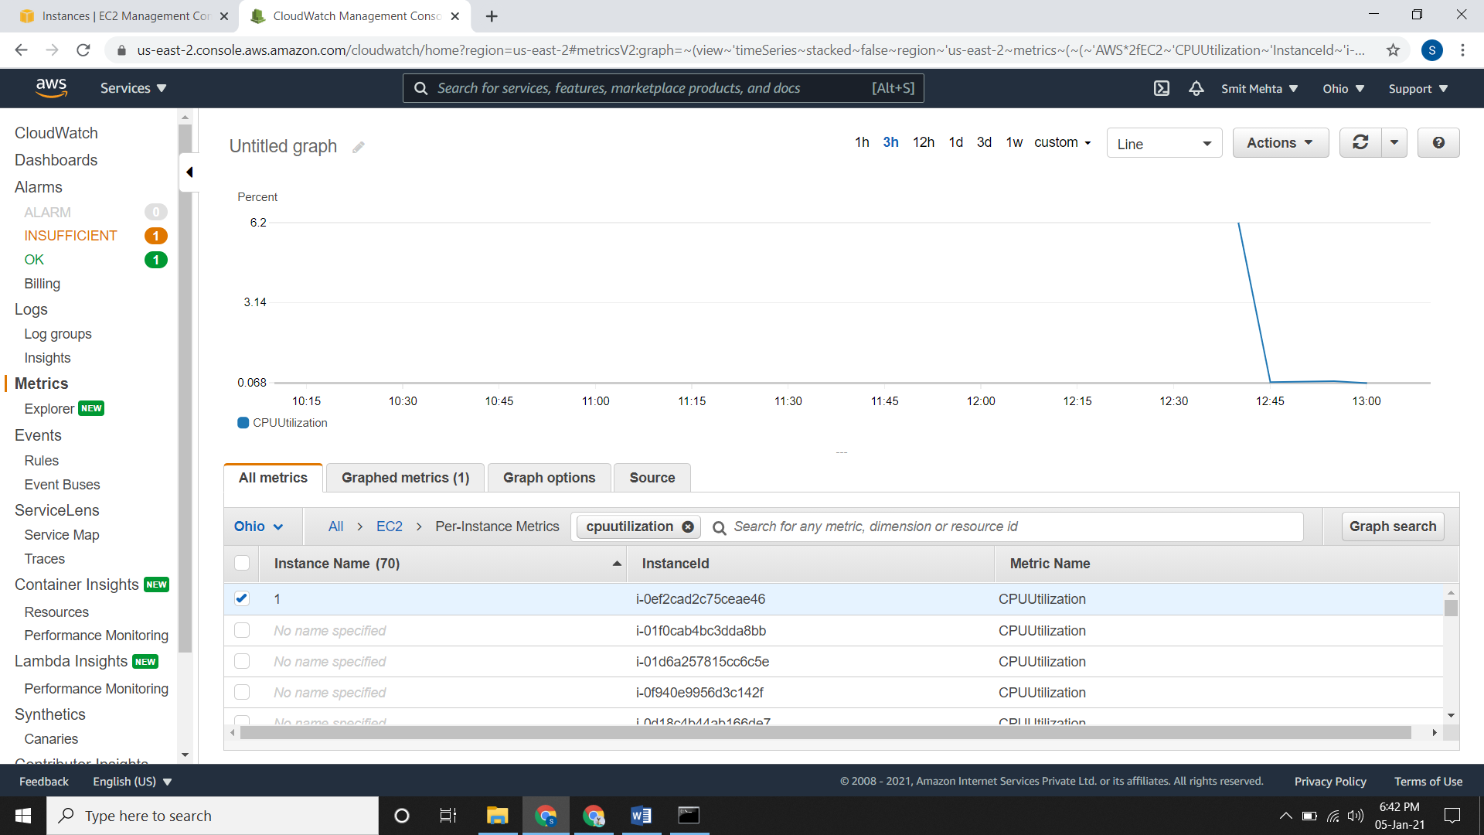

**Viewing available metric using AWS CLI**

* In the list of metric there will be multiple metric
* For that you can specify your metric according to namespace as well as through instanceId or through metric names

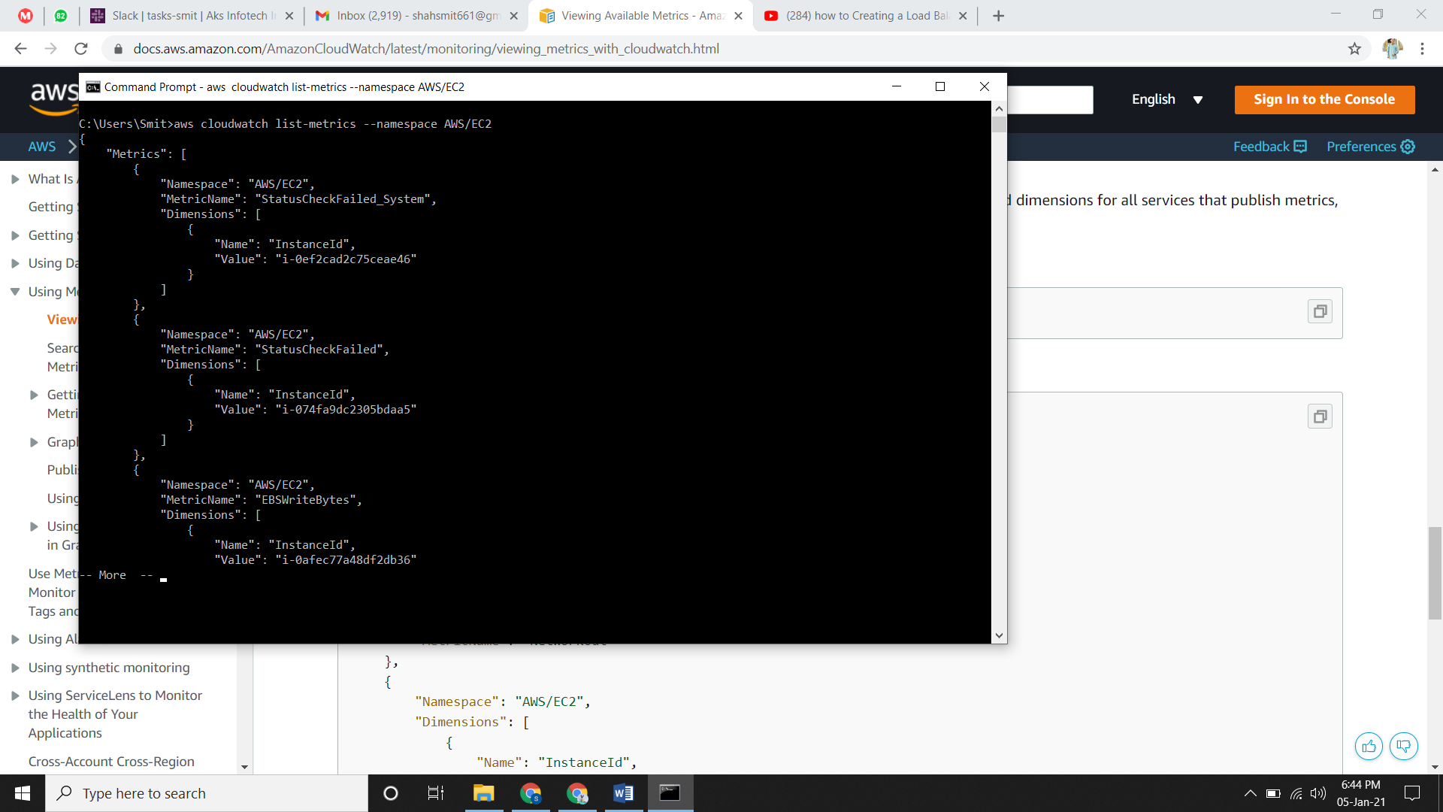

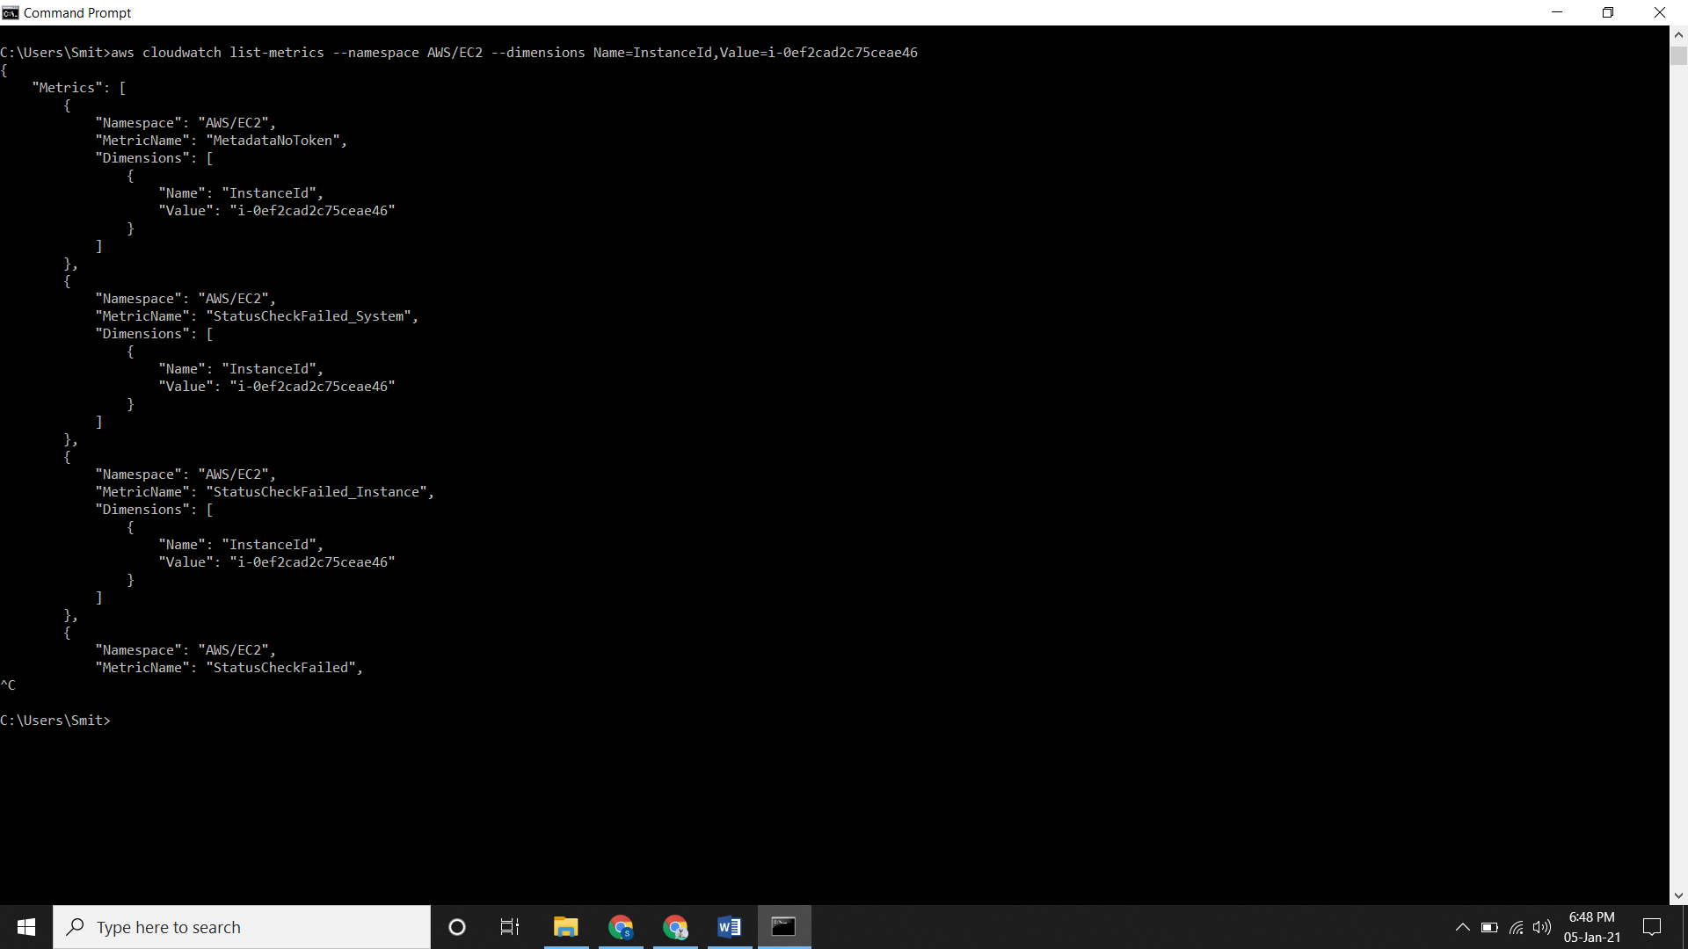

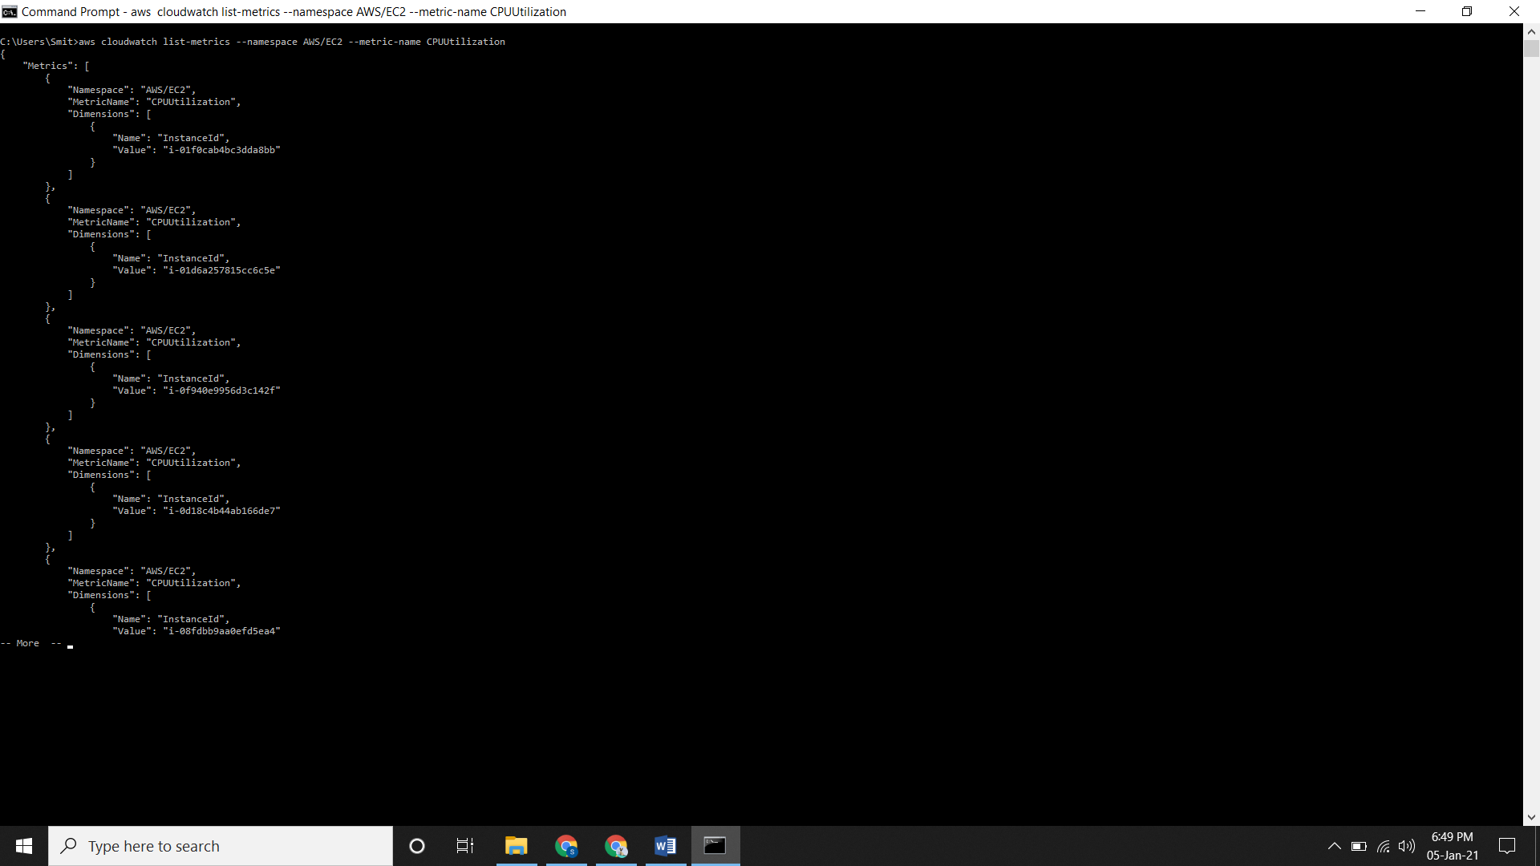

You can specific both condition in command too

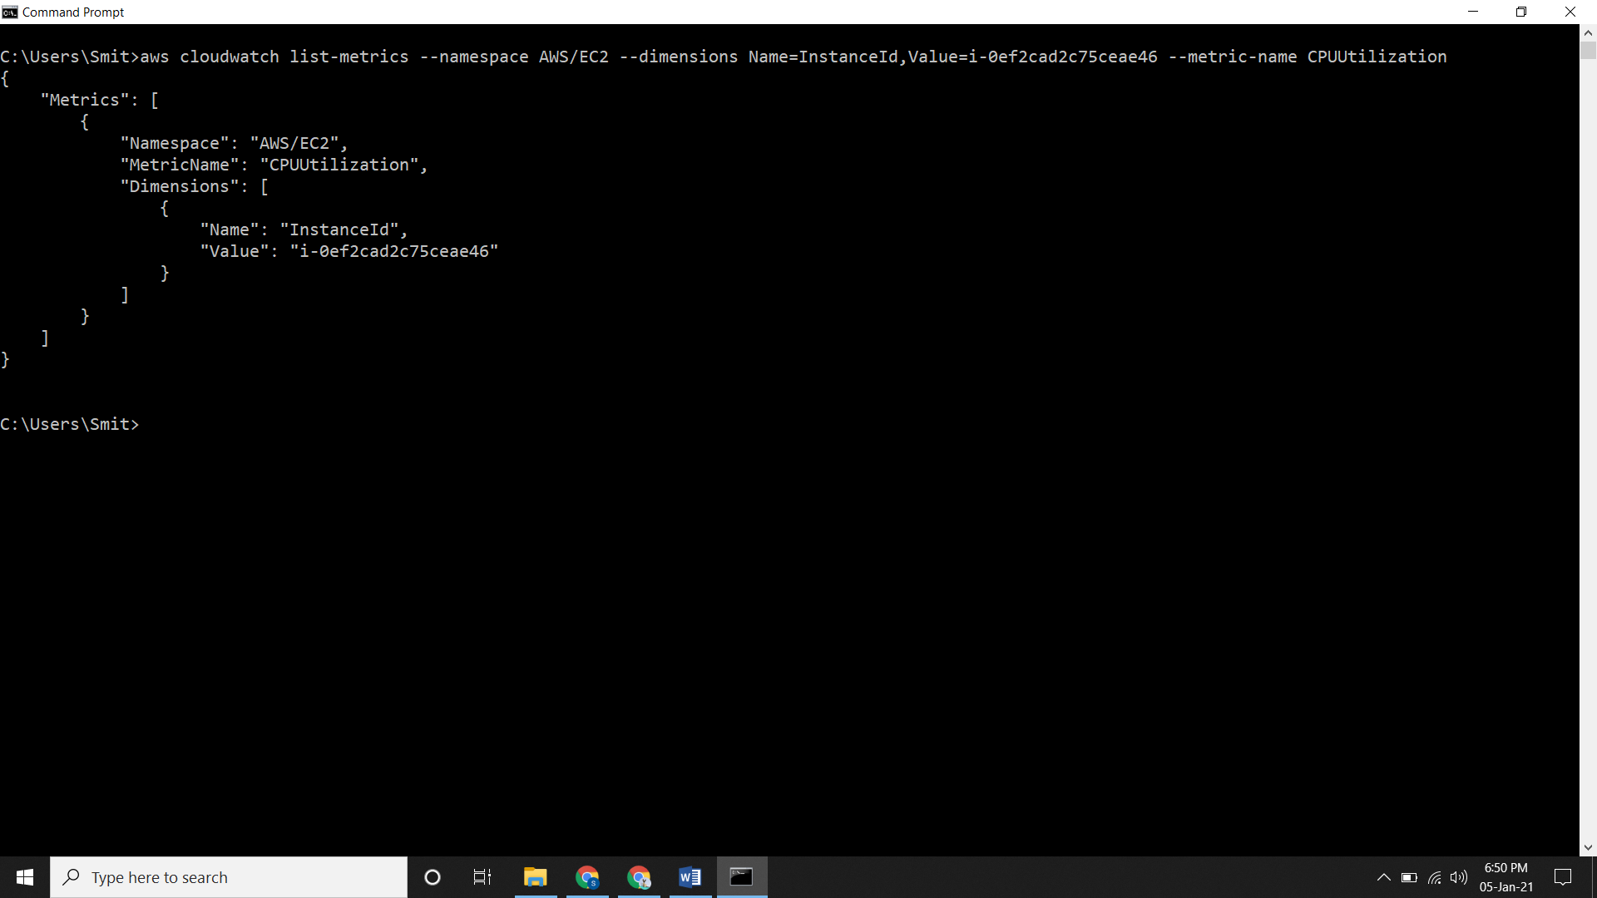

**Getting Statistics for a Specific Resource**

* Go to Metric and search for your namespace like EC2, EBS, EMR, etc. Select it and go forward.
* After going forward, you will see the instance which are running and on which metric name are they running, just select it and go to **Graphed metric.**

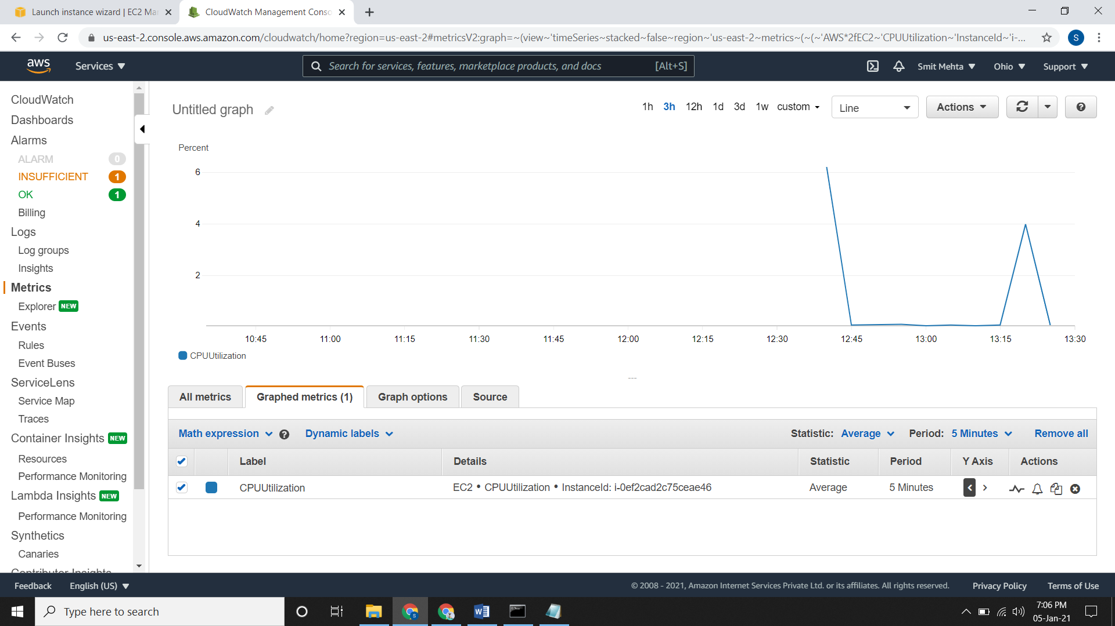

**Creating a Graph**

* Go to metric, all metric, select the namespace and search for the required metric name for ex. CPUUtilization
* Select the metric and go to **Graphed Metric.**

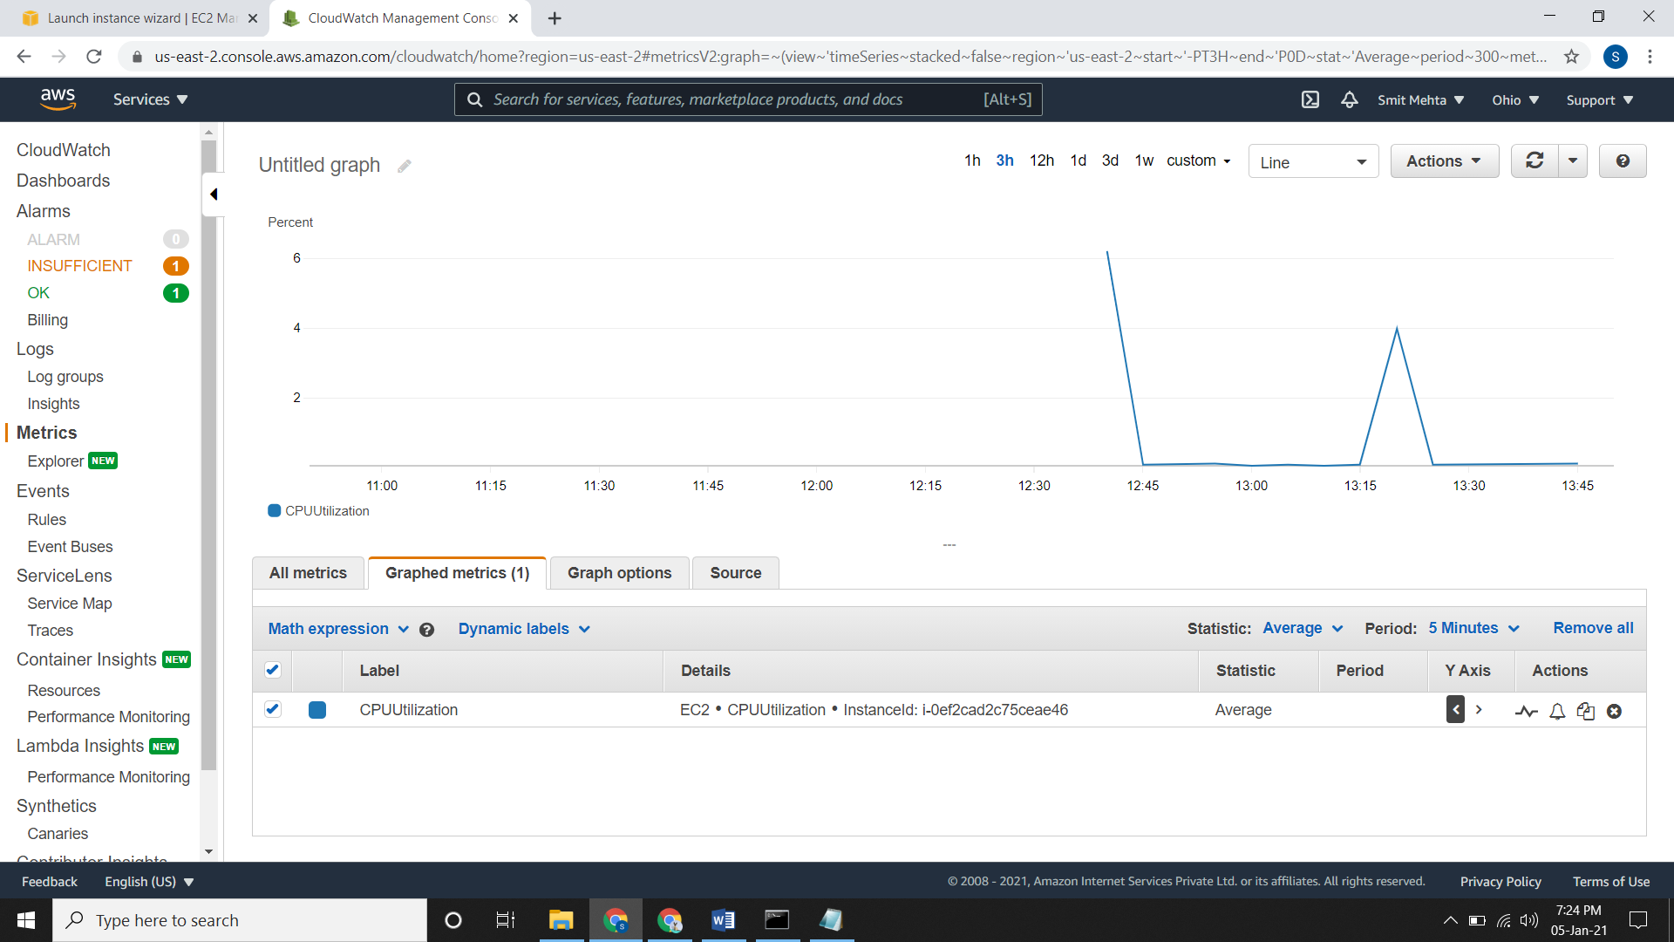

* For changing the Widget type go to **Graph Options**.

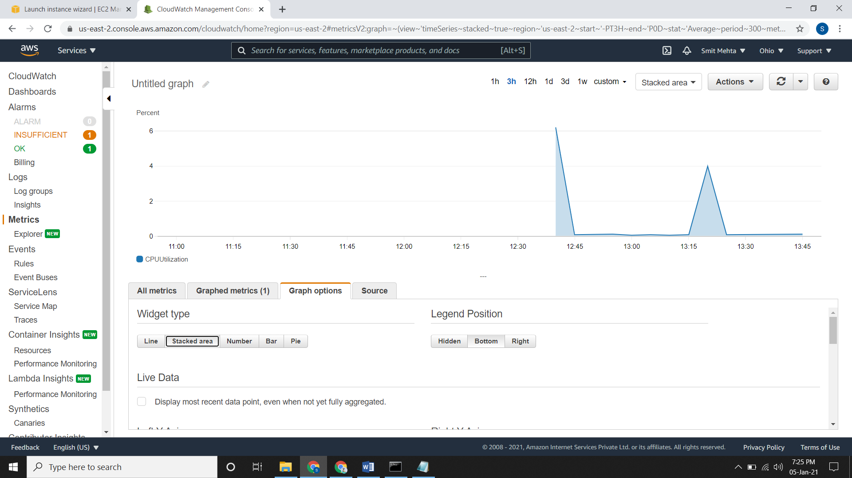

* You can change the statistic, Y-axis type and actions according to you. Here you can do

1. Enable **anomaly detection** for this metric and statistics.
2. Create **alarms.**
3. Create **duplicate** graphs.
4. Remove that graph from the screen.

* In the right upper part of screen click on **action** tab. From here you can share this graph using the URL of this graph as well as you can save it to dashboard.

**Creating an Alarm from a Metric on a Graph**

* Go to Metric and search for your namespace like EC2, EBS, EMR, etc. Select it and go forward.
* After going forward, you will see the instance which are running and on which metric name are they running, just select it and go to **Graphed metric.**
* At the right side of the instance you will see an **actions** label, in that there will be a bell icon. Click on it and you will be directed to the creating alarm page. After clicking,

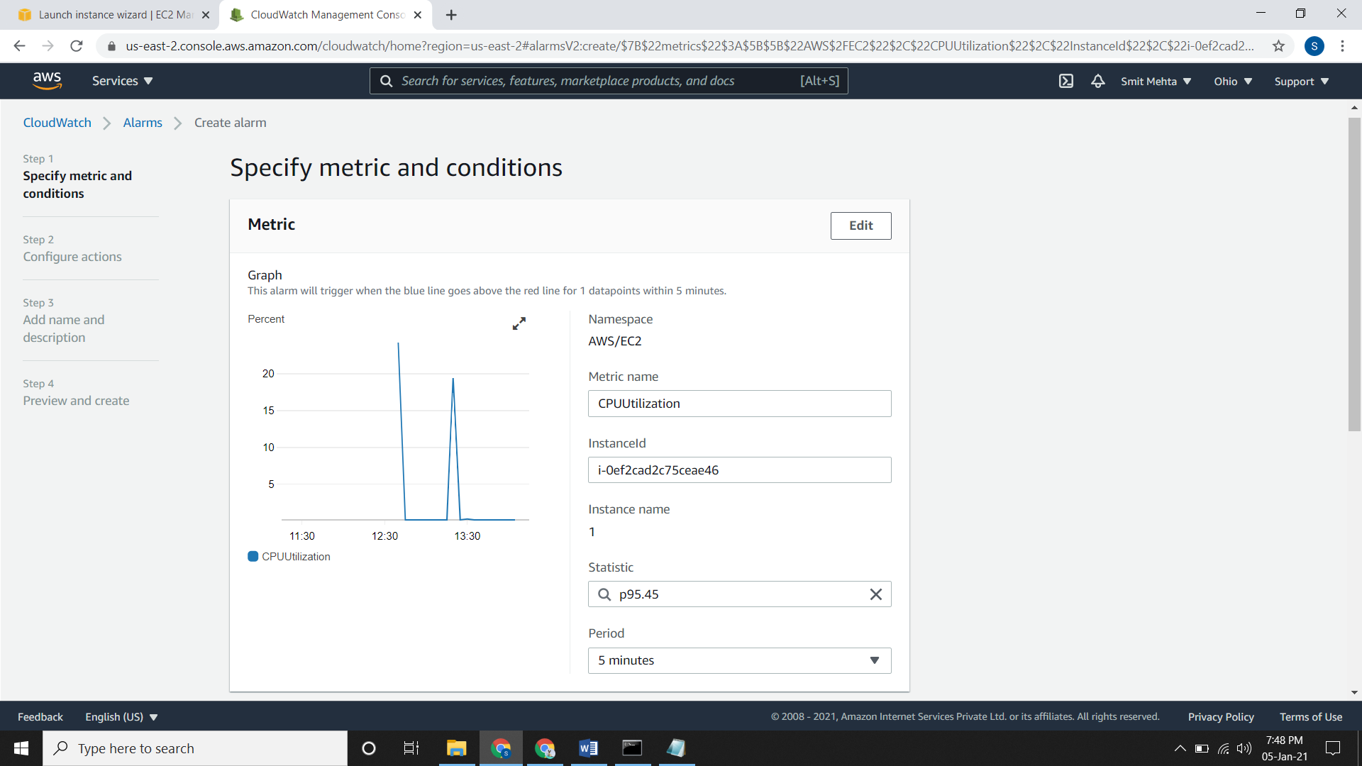

* Now give your requirements and create it.

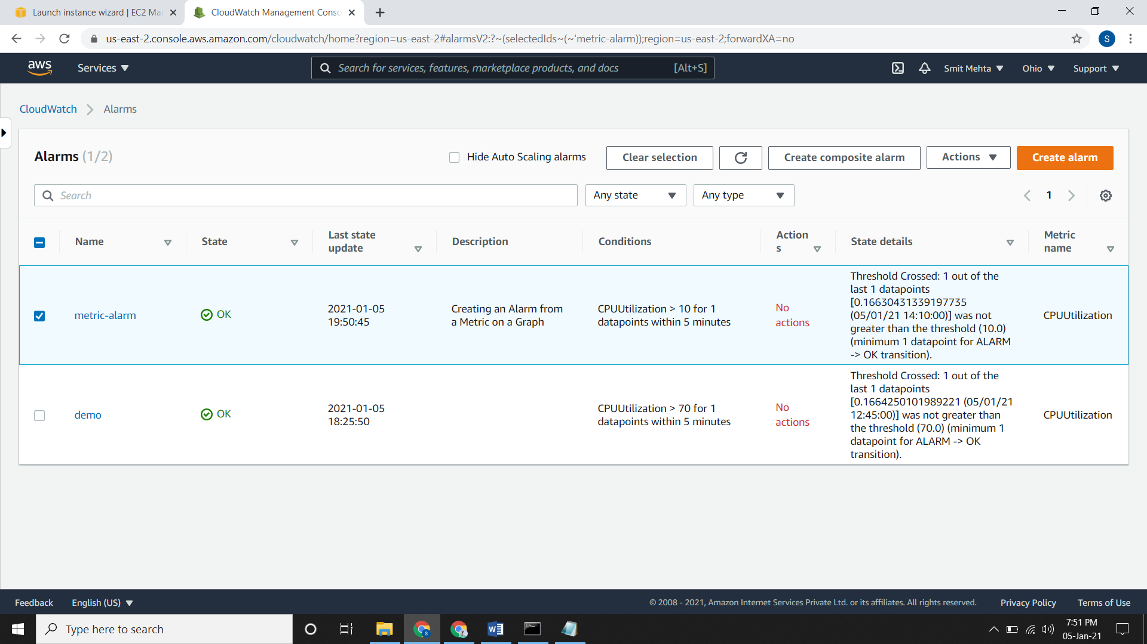

**Adding a Math Expression to a CloudWatch Graph**

* Go to Metric and search for your namespace like EC2, EBS, EMR, etc. Select it and go forward.
* After going forward, you will see the instance which are running and on which metric name are they running, just select it and go to **Graphed metric.**
* Now choose the **Math expression** tab and add a **Start with empty expression** tab.
* Write an expression for ex. m1/m2 for this you need two graphs as id’s of both graph will be m1 and m2 or you can change it.

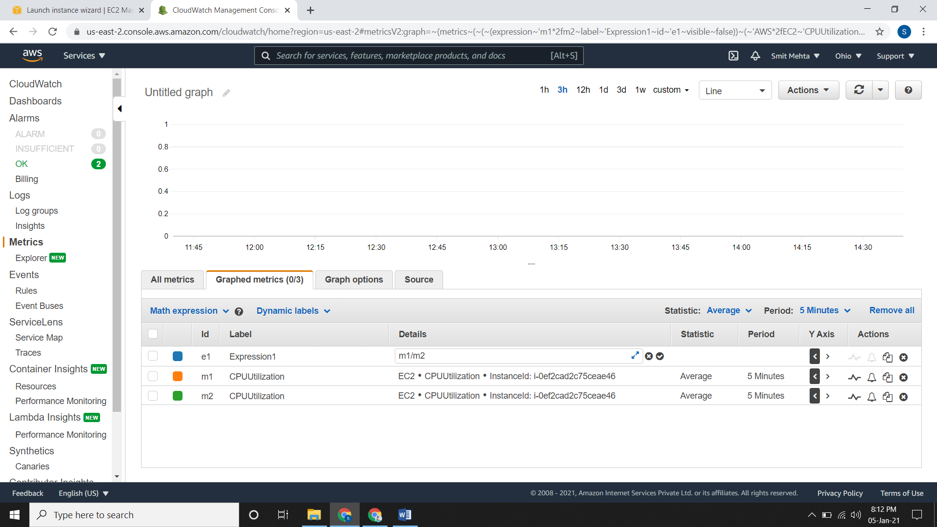

**Creating a CloudWatch Graph with a Search Expression**

* Go to Metric and search for your namespace like EC2, EBS, EMR, etc. Select it and go forward.
* After going forward, you will see the instance which are running and on which metric name are they running, just select it and go to **Graphed metric.**
* Now choose the **Math expression** tab select the **Search expression** and choose any one according to the requirement. For ex. **EC2 CPU Utilization.** A new row will be added

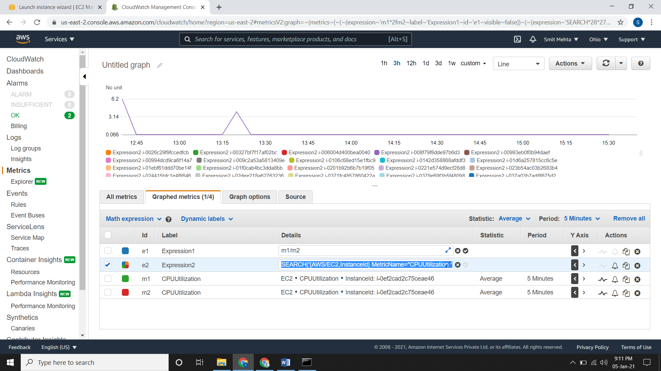

**Use Metrics Explorer to Monitor Resources by Their Tags and Properties**

* Open CloudWatch, go to Explore. Select a template as **Empty Explore** or if you already had a template use it.
* In the **Metric** section choose which type of metric you want to have for the instances.
* Under **From** section, choose a tag or a resource property to filter your results. Here you can apply multiple filters.
* In **Aggregate** section choose the statistic which you want.
* In **Split by** section, you can choose to split a single graph with multiple time series into multiple graphs.
* Lastly add the **Graph Options** and create it i.e. add to dashboard.

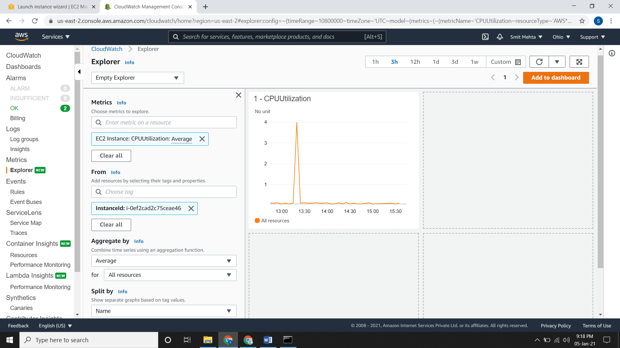

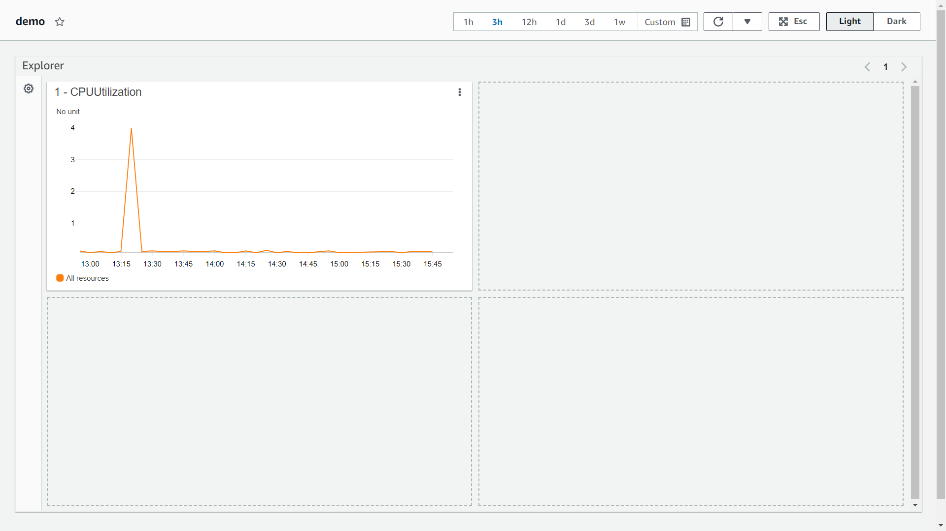

**EVENTS**

**Lambda Function:**

* It is a server less compute service that runs your code in response to events and automatically manages the underlying compute resources for you.
* Here we can start/stop instances according to our requirement.
* Firstly, you need to create some policies for it.
* Go to **IAM**, click on **create policies.** Choose the **service,** add some **actions** and **resources,** review it and create it.

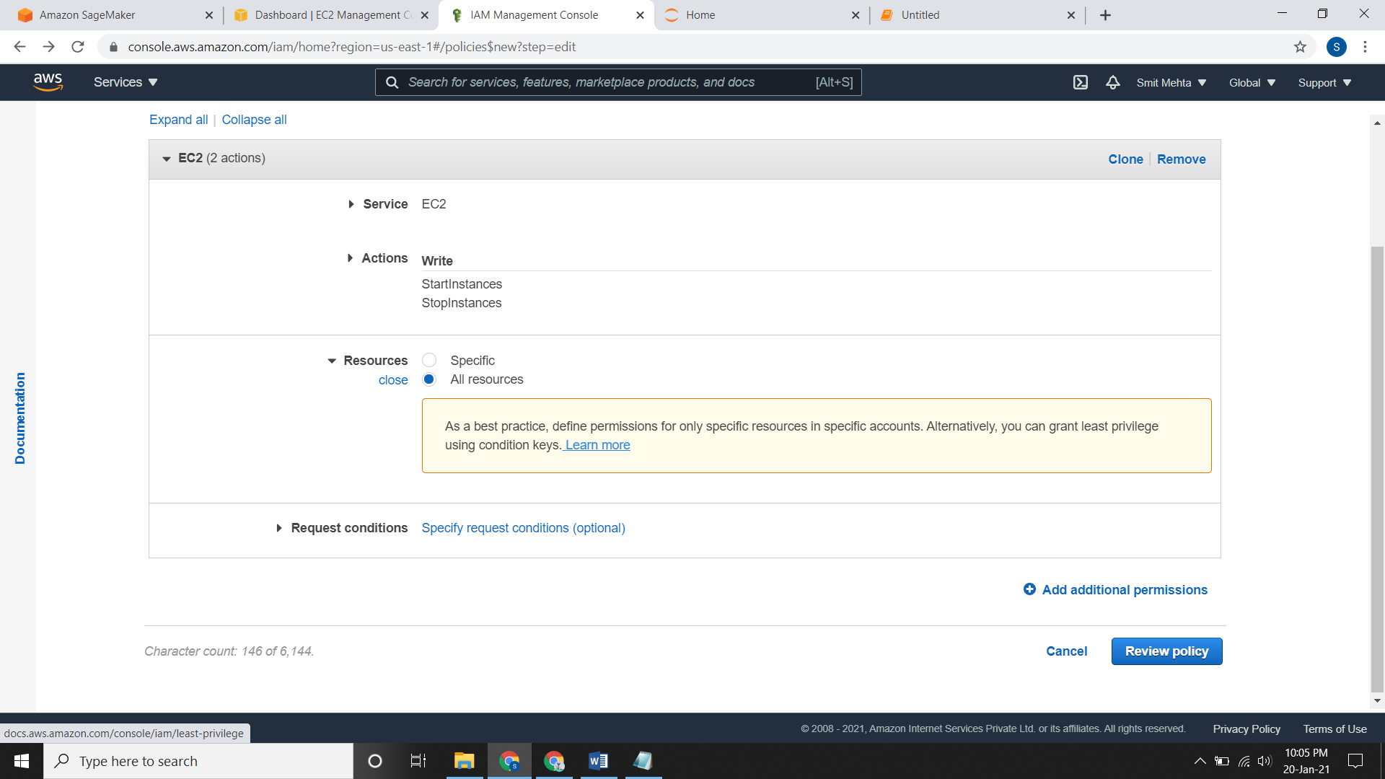

* Now you need to create a role and assign this policy to it.
* So go to **Role** create a new role, under **choose a use case** select **Lambda,** go next to permissions and select the **policy** you just created, review it and create it.

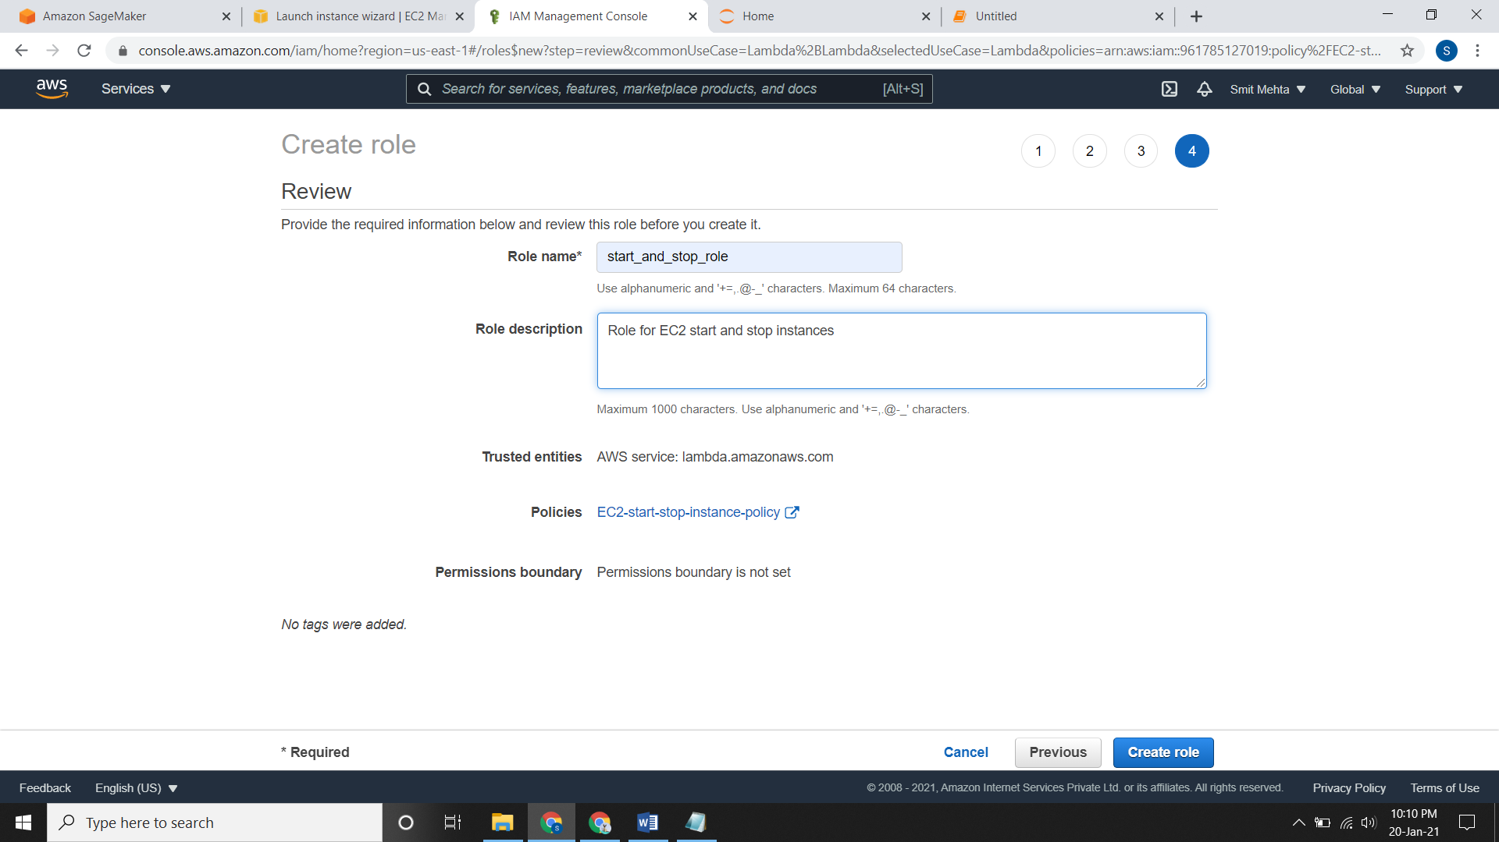

* Go to **Lambda** console and click on **create function**.
* Select a function, give a name to it, choose the runtime in which you are going to write your code and give a **role** to it which you have created create it.

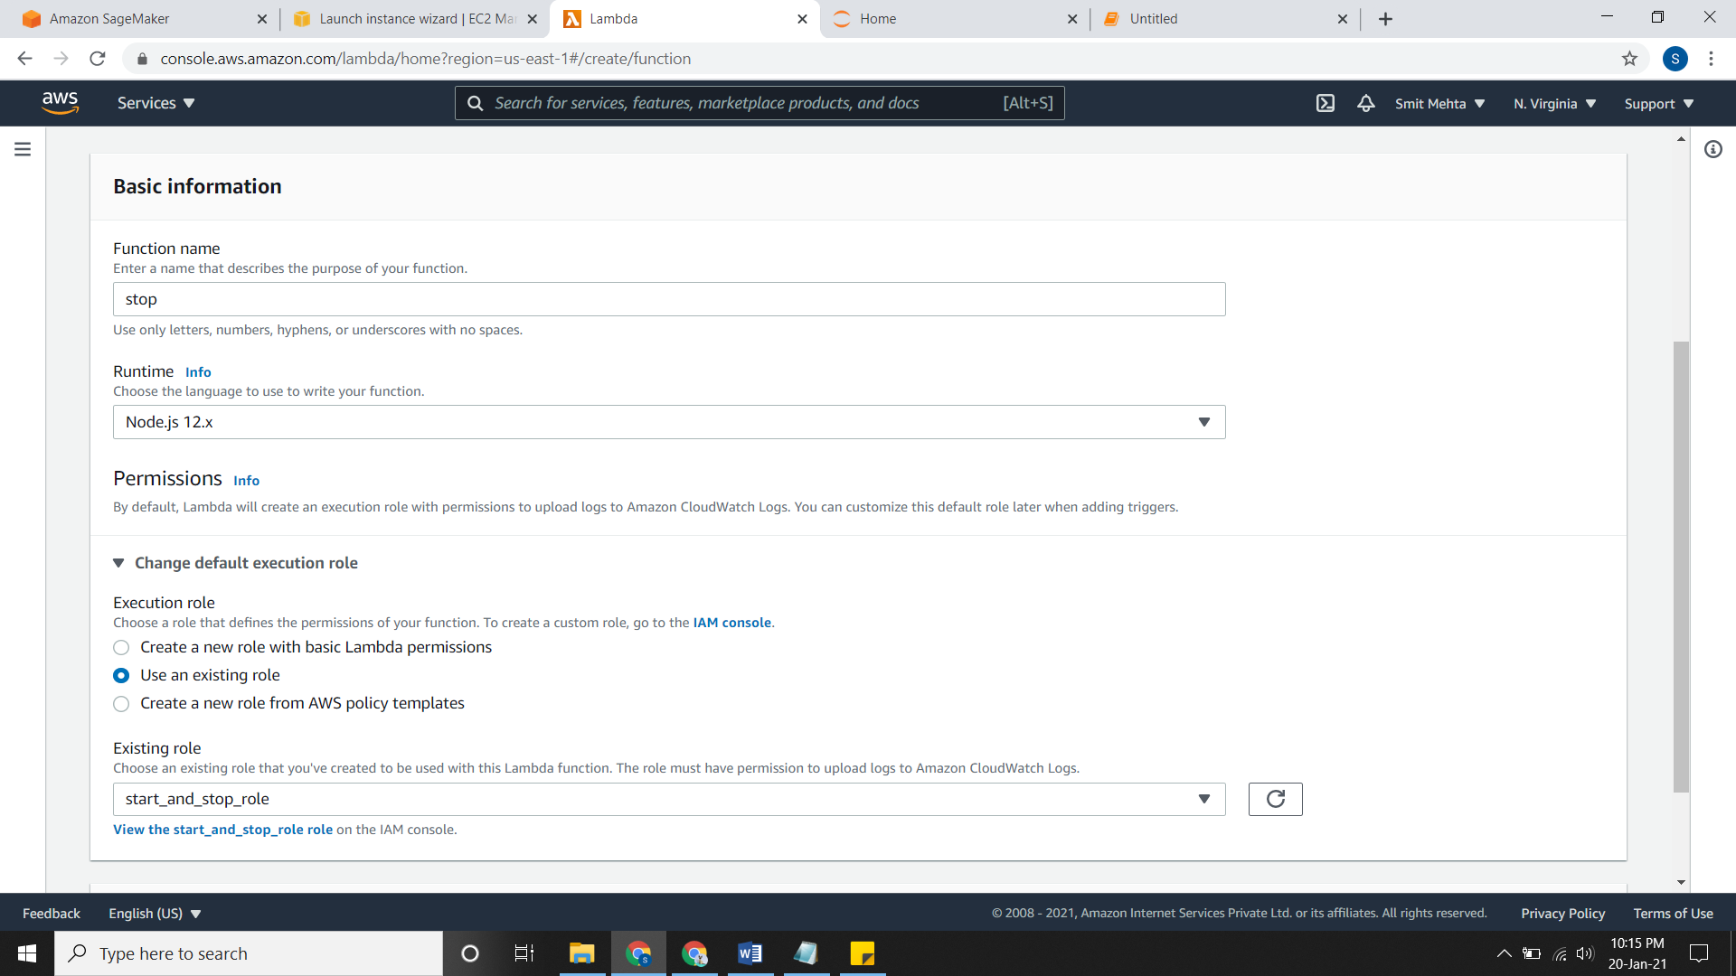

* Now you need to write the code by which the instances will get start/stop.

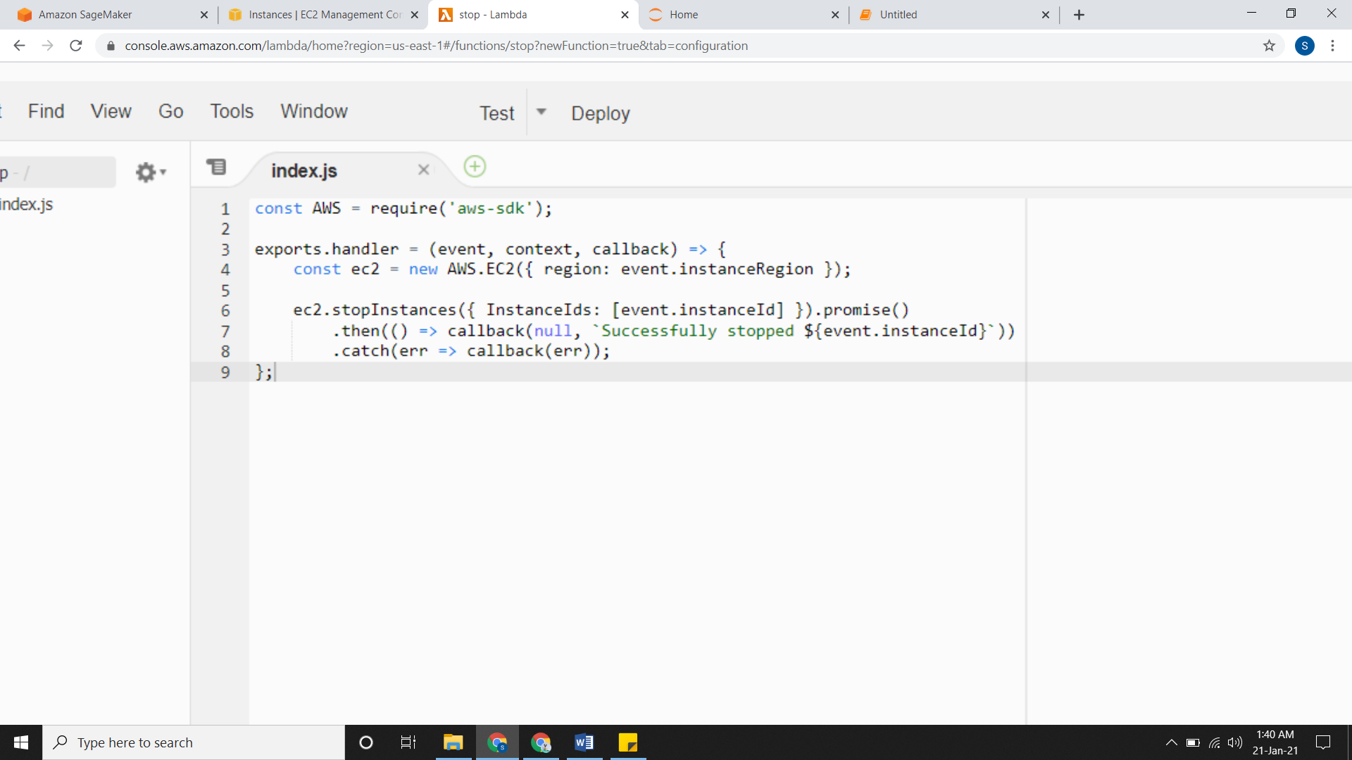

* After writing the code you need **test** the configuration and then **deploy** it.

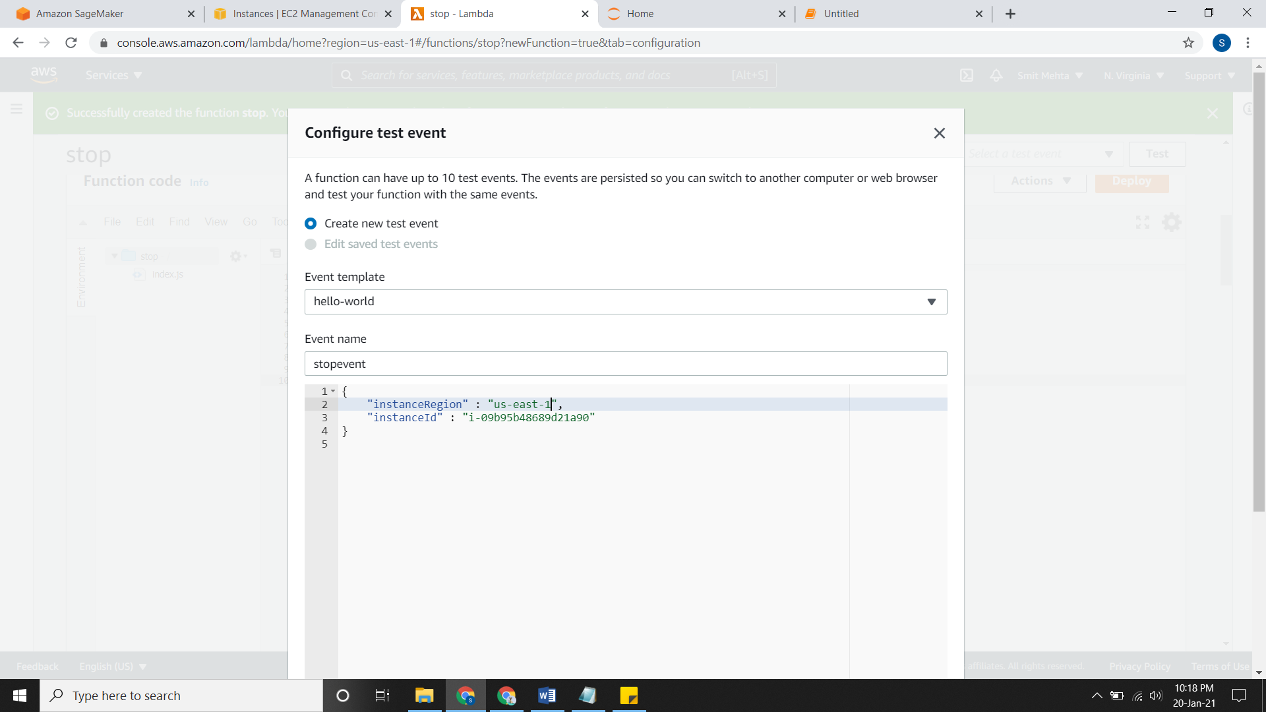

* After deploying the code click on **Test** and if your code works successfully scroll up and open the **details**.

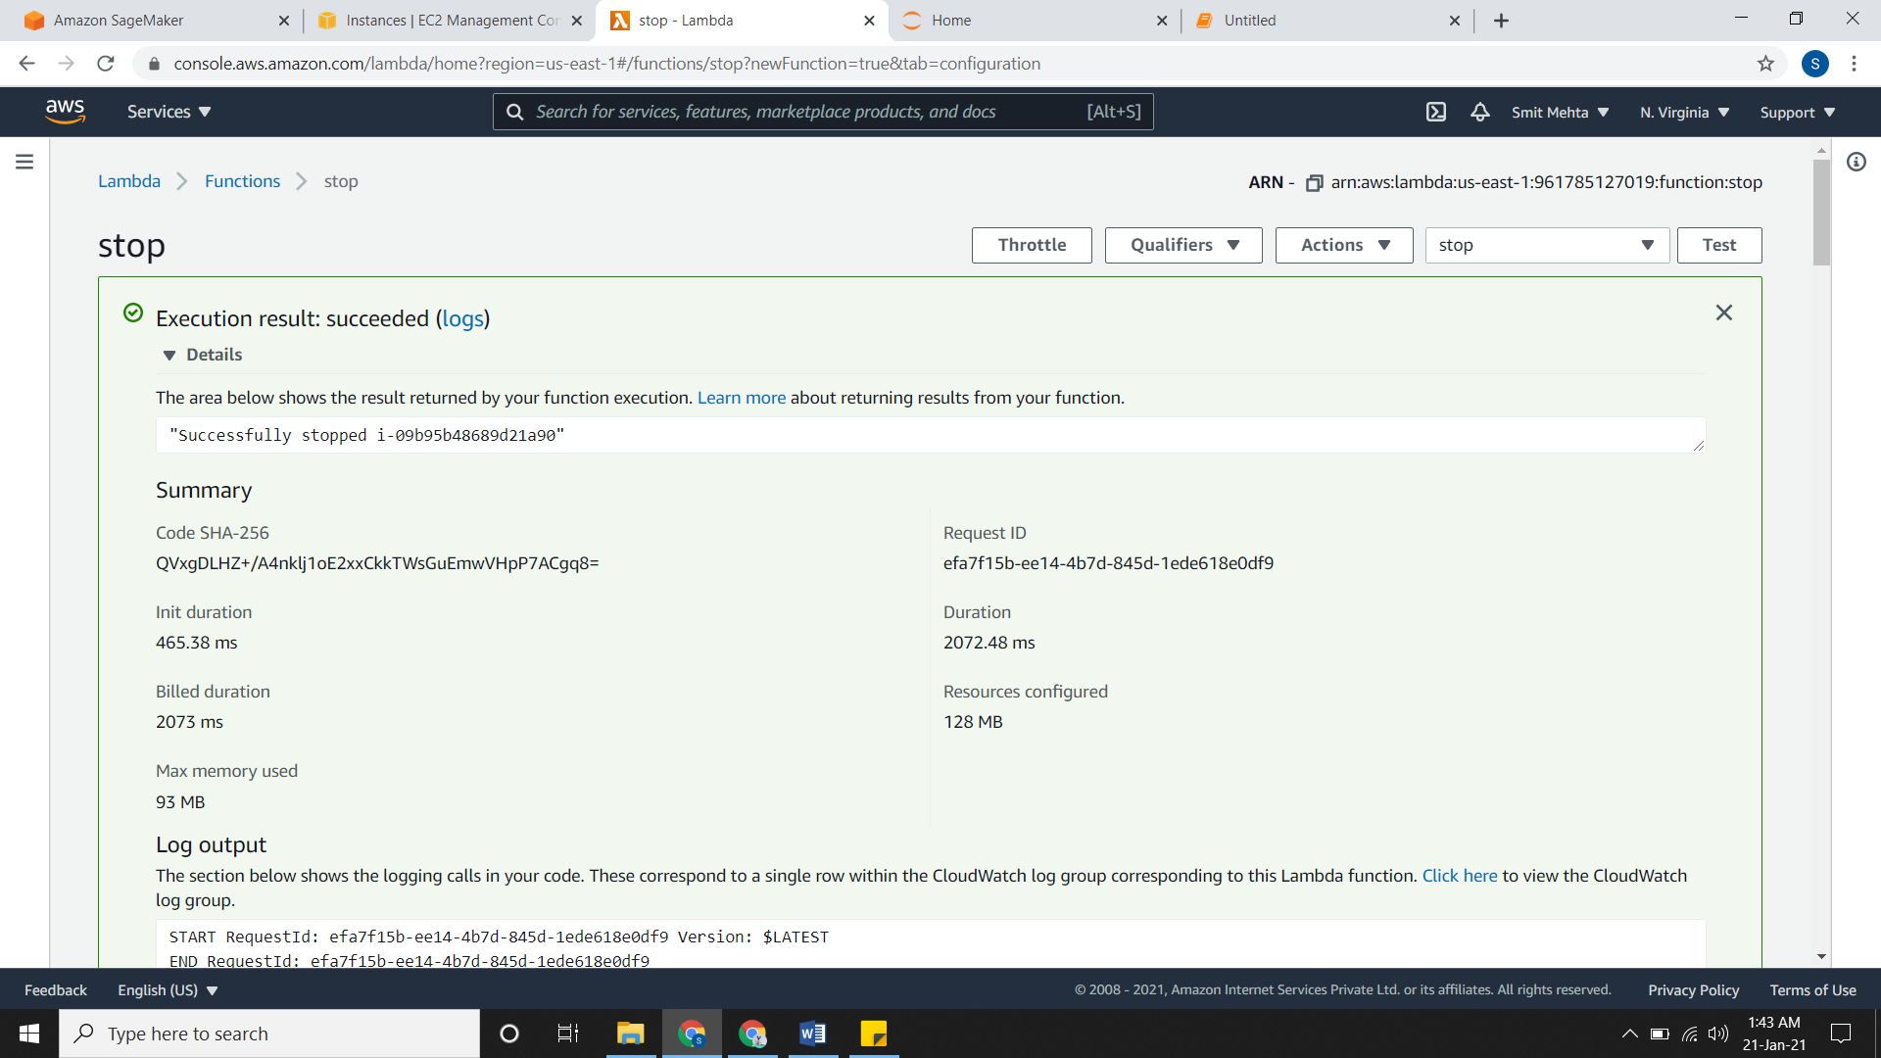

* Cross-check that it works and see the **instance.** It should have stopped.

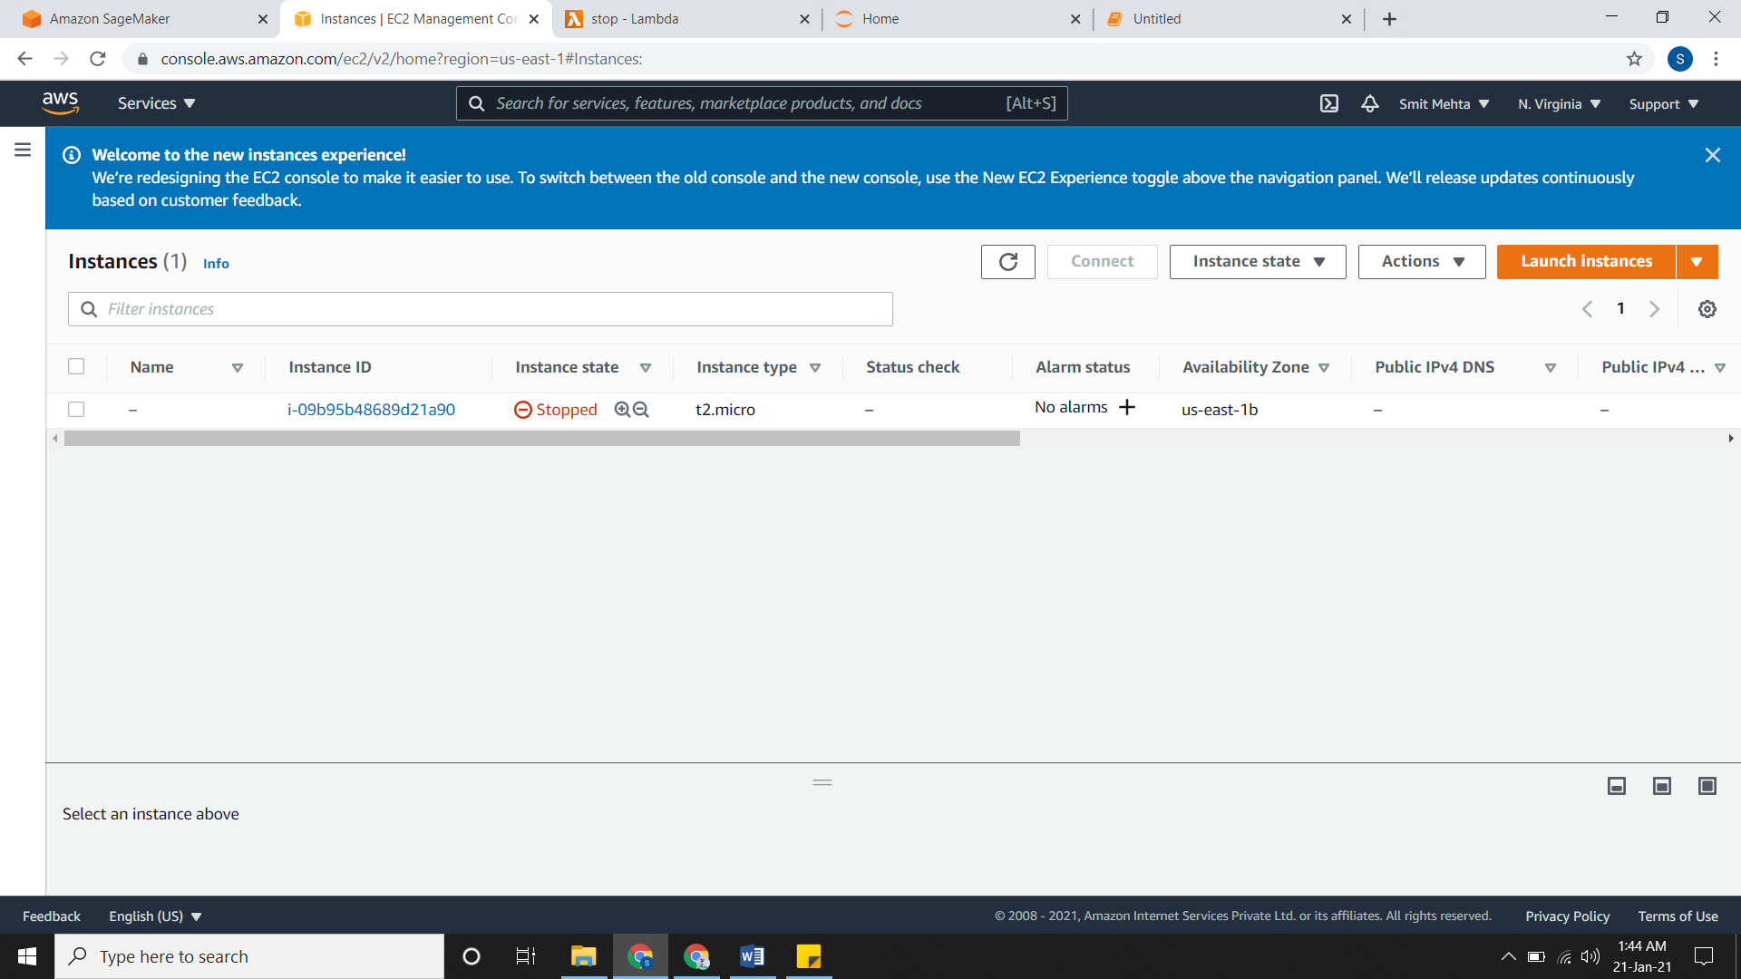

* Accordingly, do it for **starting** the instance.
* Creating the **start** function.

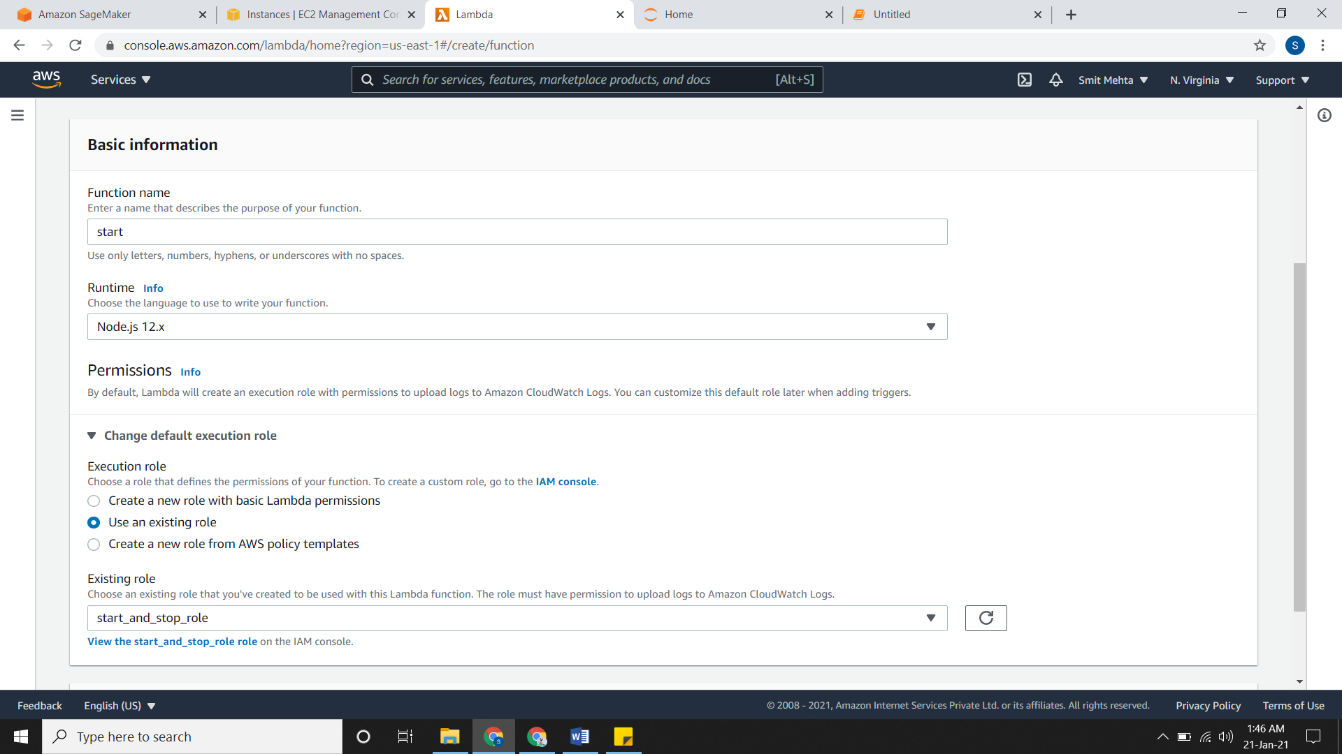

* Code for starting the instance

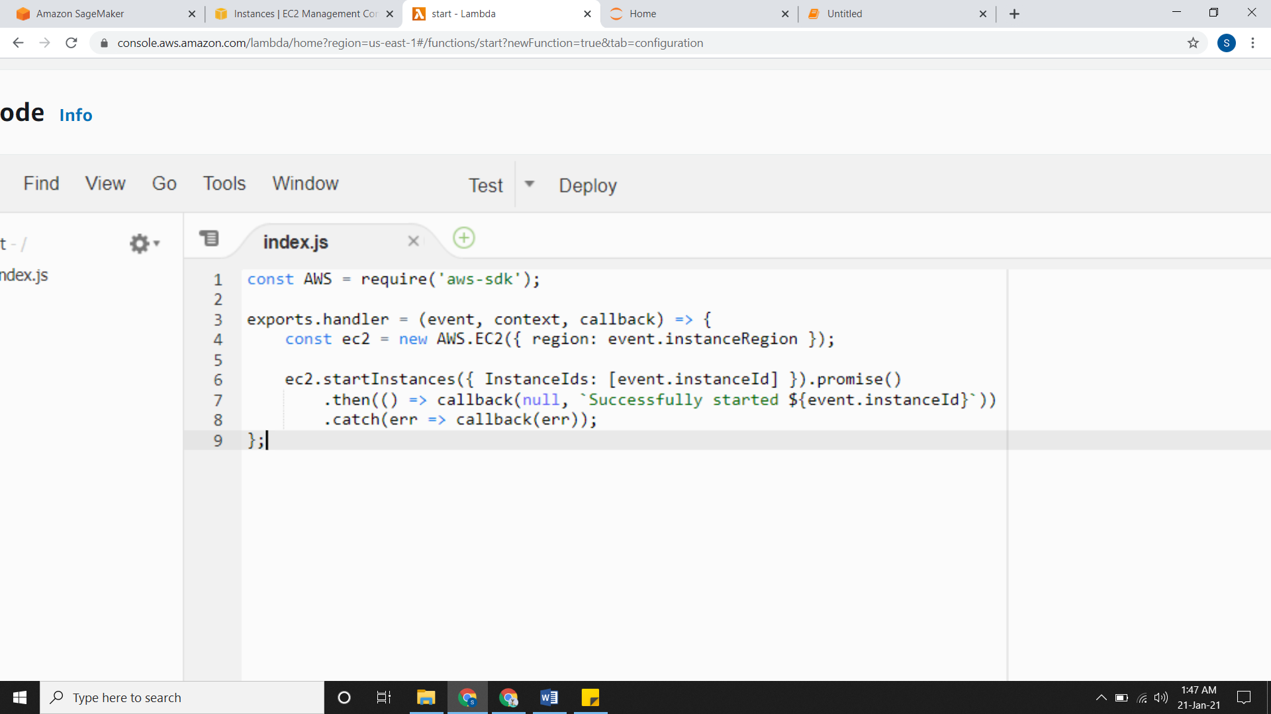

* Configuring **test event** and deploying it.

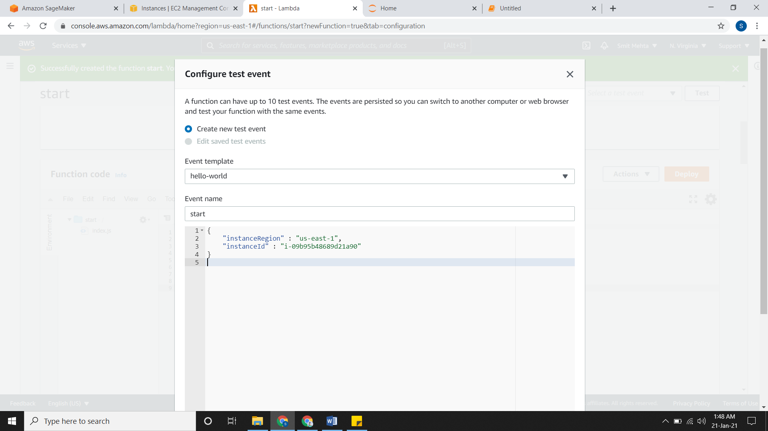

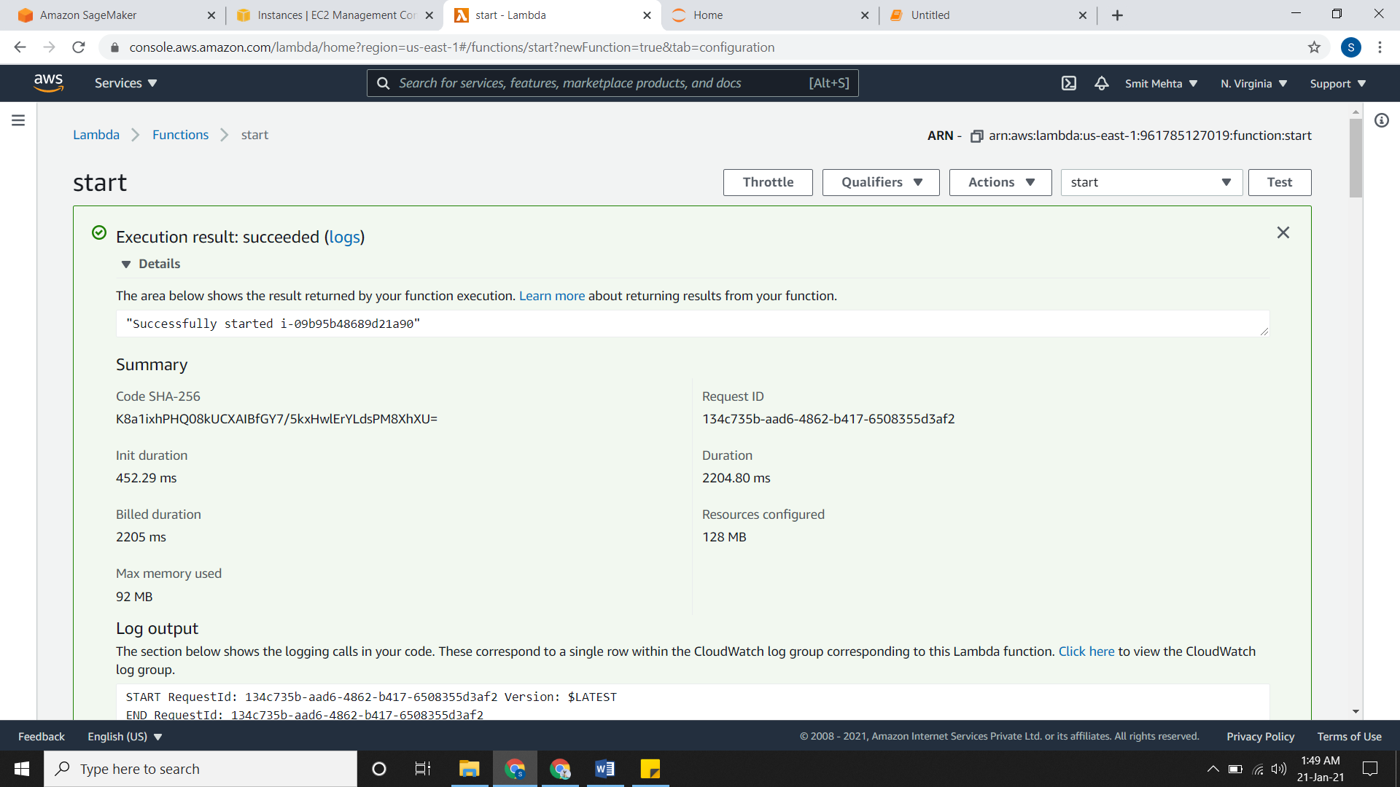

* Checking the instance

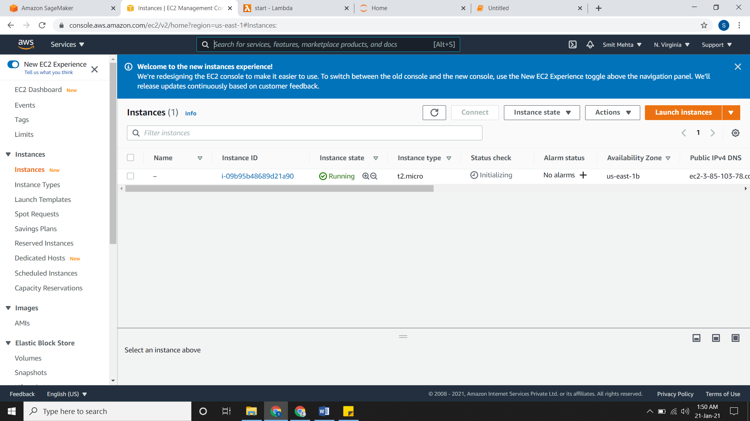

**Backing Up Data by using Lambda Function**

* We will create a backup storage in S3. So as the data is stored in S3 is also gets stored in another bucket which we have specified.
* 4 steps to do:

1. **Creating two S3 Buckets**

* Just create two S3 buckets.

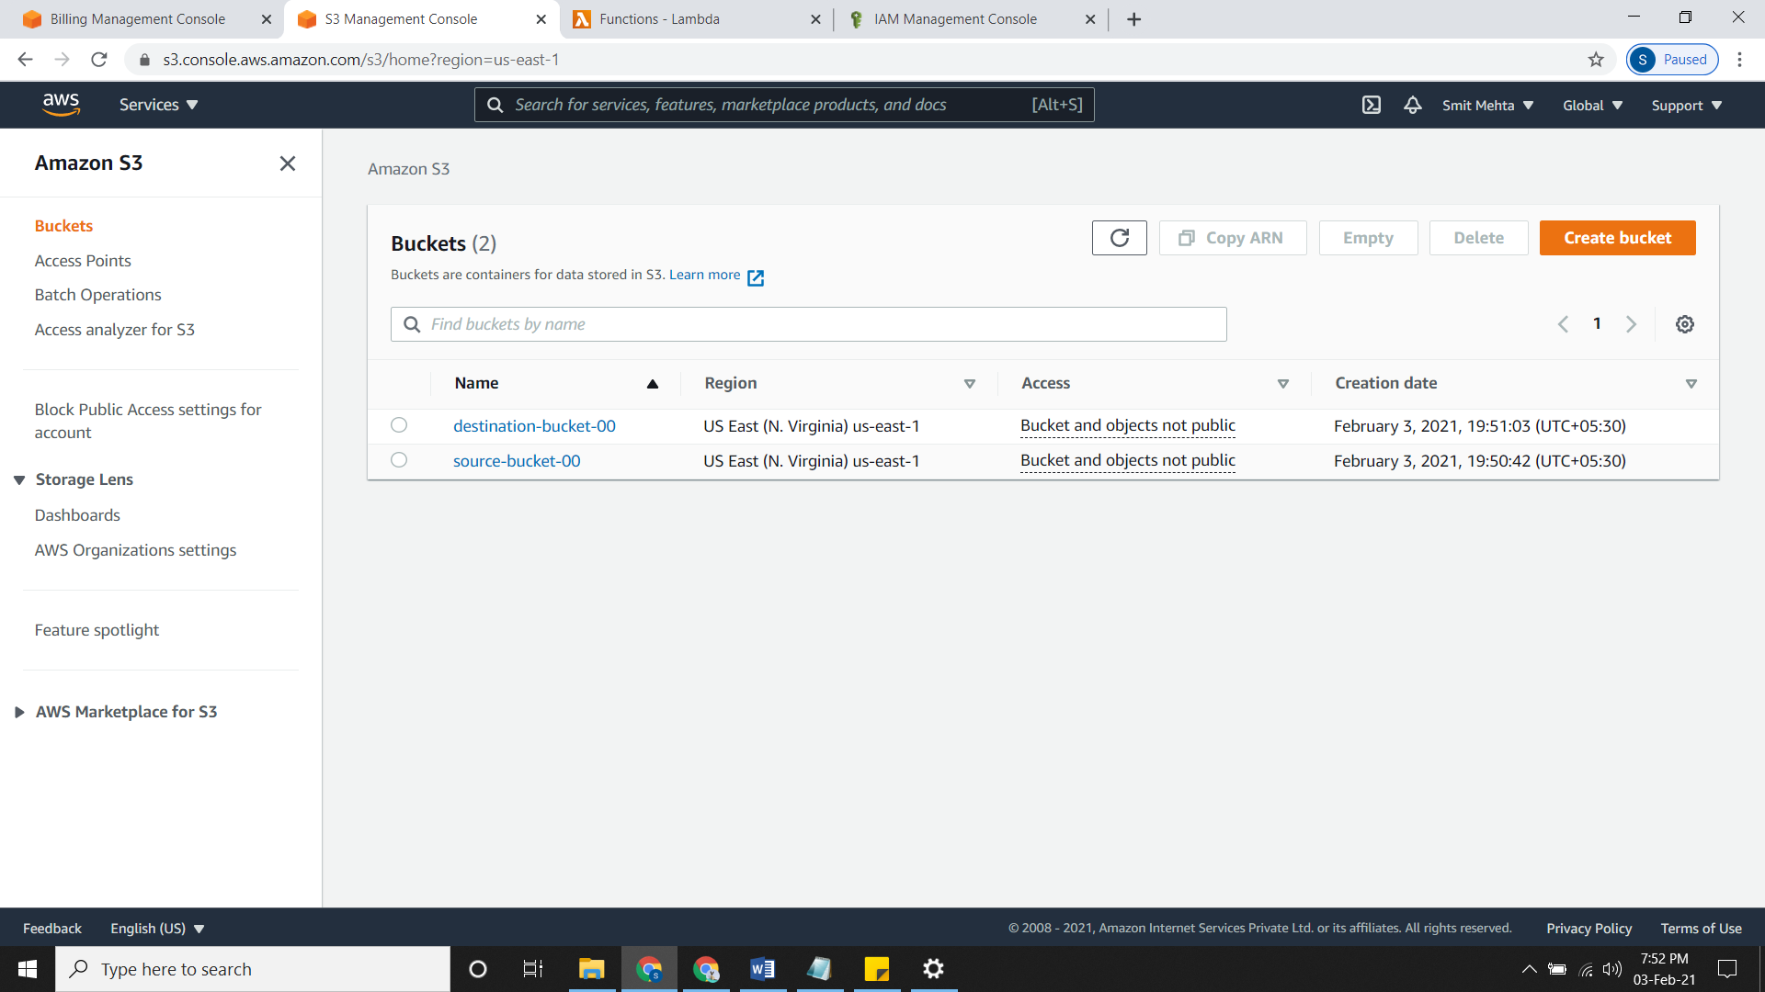

1. **Creating IAM Policies and Roles**

* Create a policy as Action = GetObject from source bucket ARN and Action = PutObject from destination bucket.

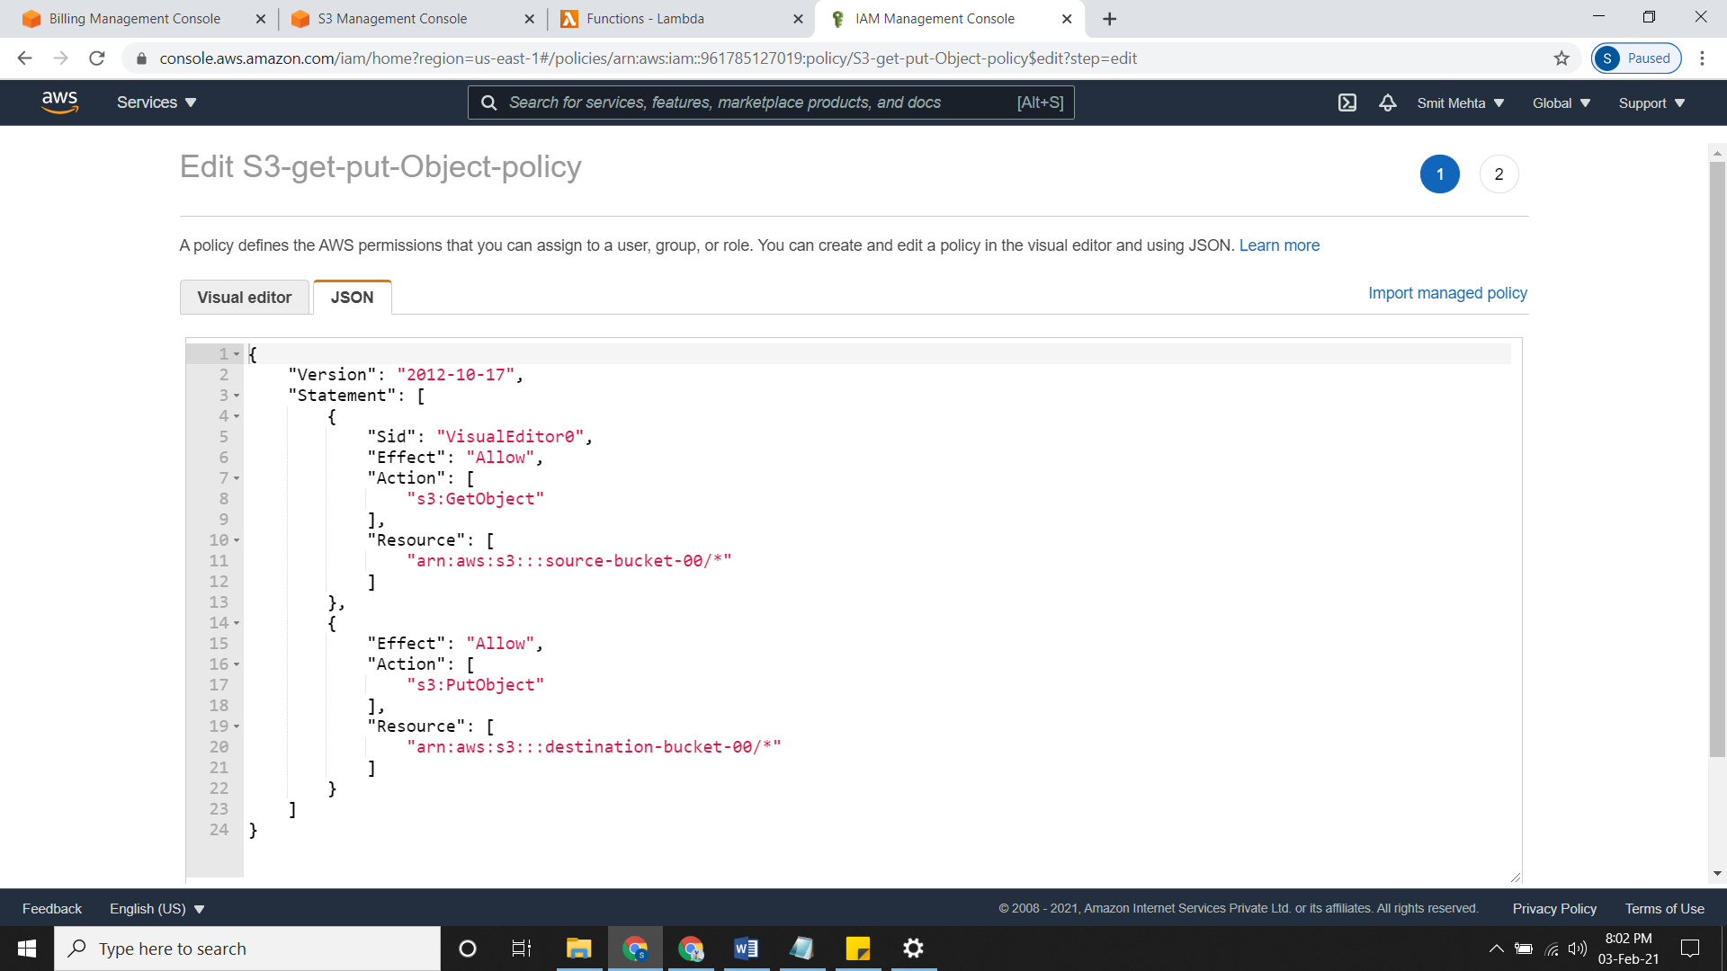

* Now create a Role for LAMBDA and attach the policy.

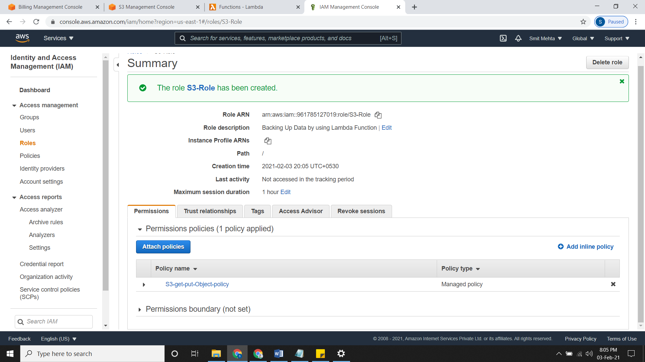

1. **Creating LAMBDA Function for coping data.**

* Create a Lambda function and select the role we created under **Change the default role.**
* Inside the **index.js file** clear it up and write the code for backing up data.

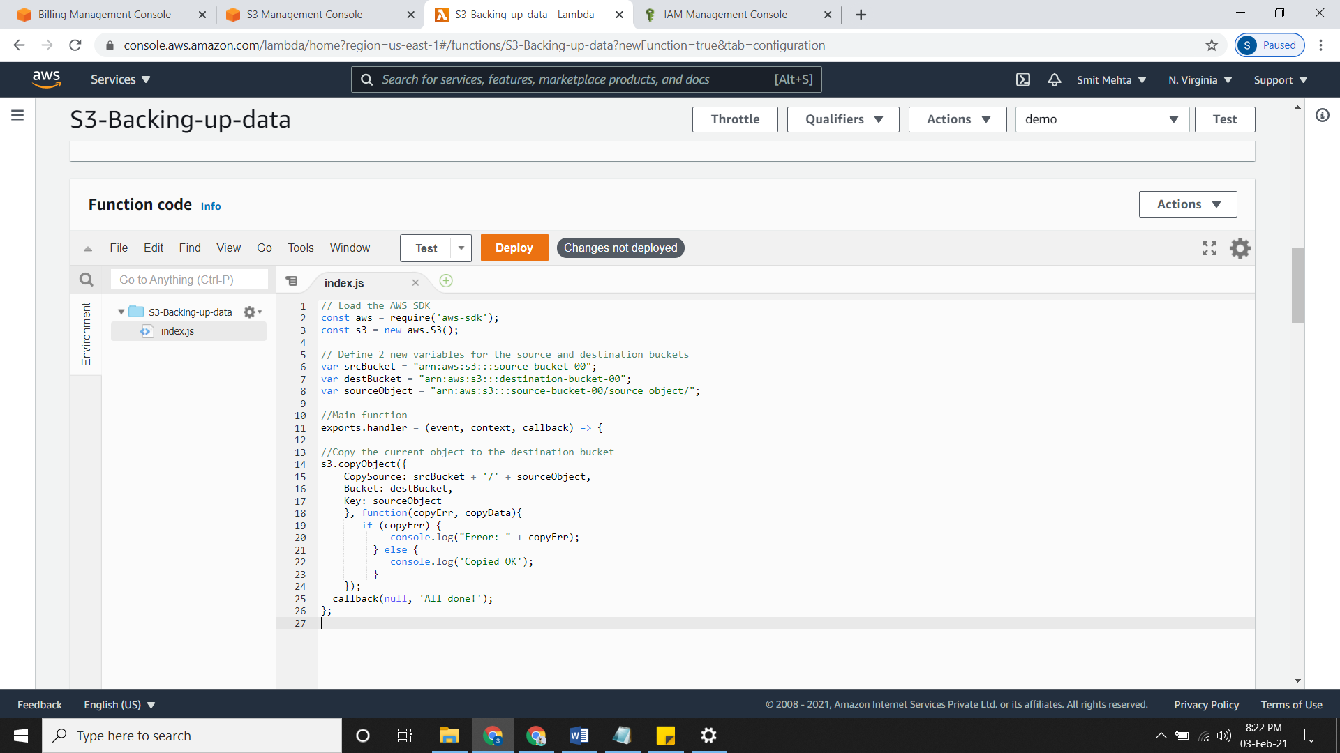

* Now configure it by clicking on **Configure test event** and give a name to it.
* Now for running the Lambda Function click on **Test.**

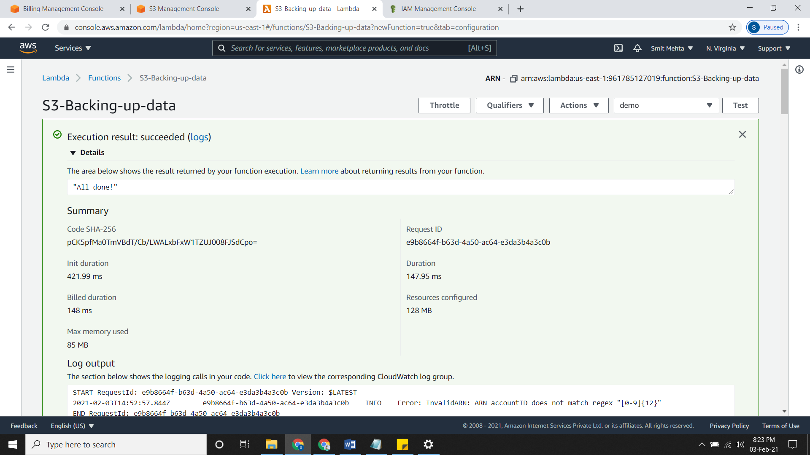

1. **Testing it.**

* Now we will upload some data in our source bucket.

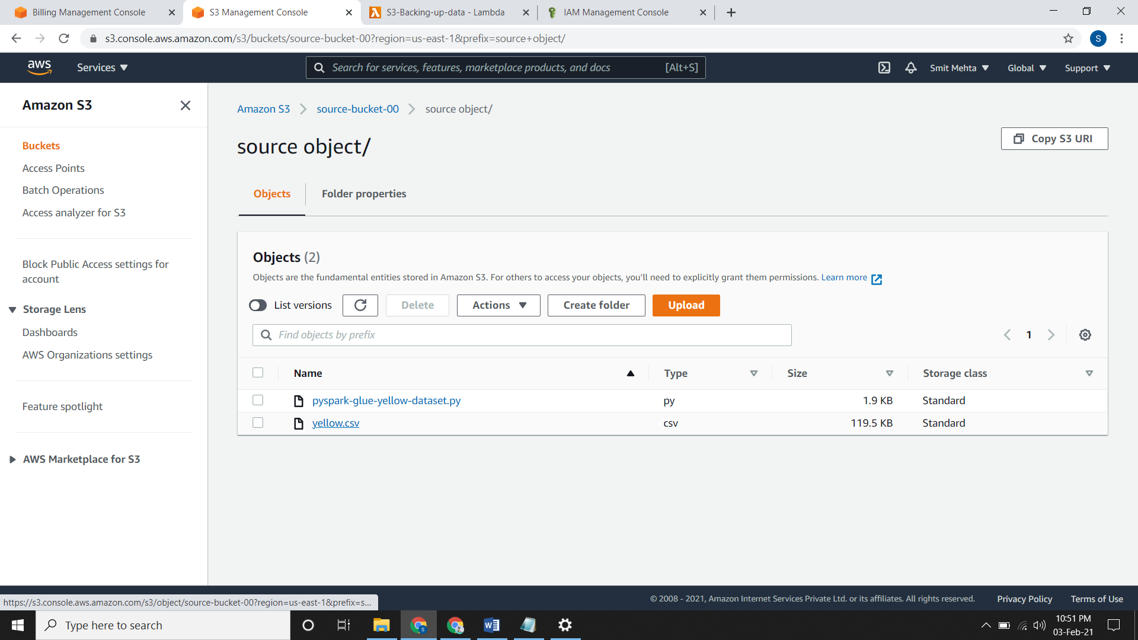

* Now we check our destination bucket, it will contain all these files too.

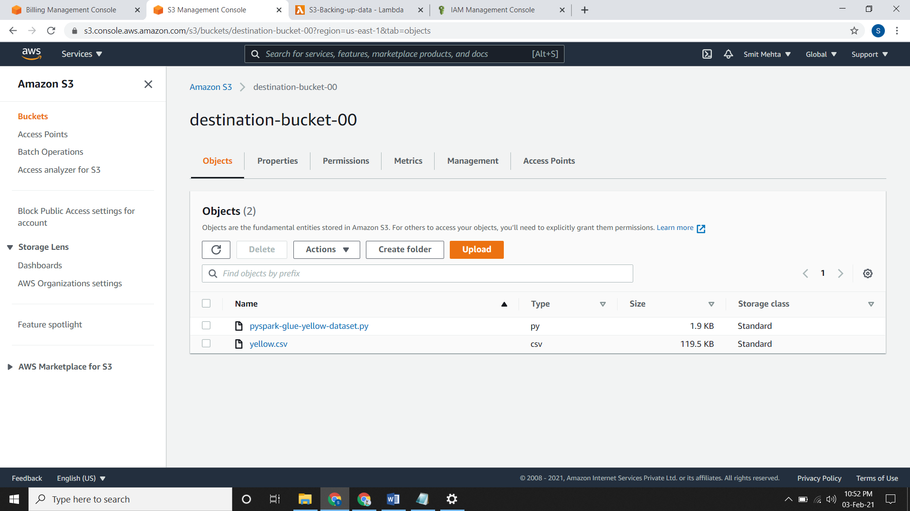

**CLOUDWATCH EVENTS**

* The CloudWatch Events Build or customize a pattern or set a schedule to invoke Targets.
* So as we have start & stop using lambda we can do it by the CloudWatch Events.
* By Events we can automate this process and start & stop instances according to our timing.

**Event Pattern**

* Go to **events**, click on **Event Pattern,** select a **service** and choose the **Event type.**
* Under **targets** select the **Target function** and then select the function.
* Select the **Configure version/alias and input** accordingly and if not it gets selected by default.
* You can add many targets by clicking on **add targets,** select it, review it and **create rule**

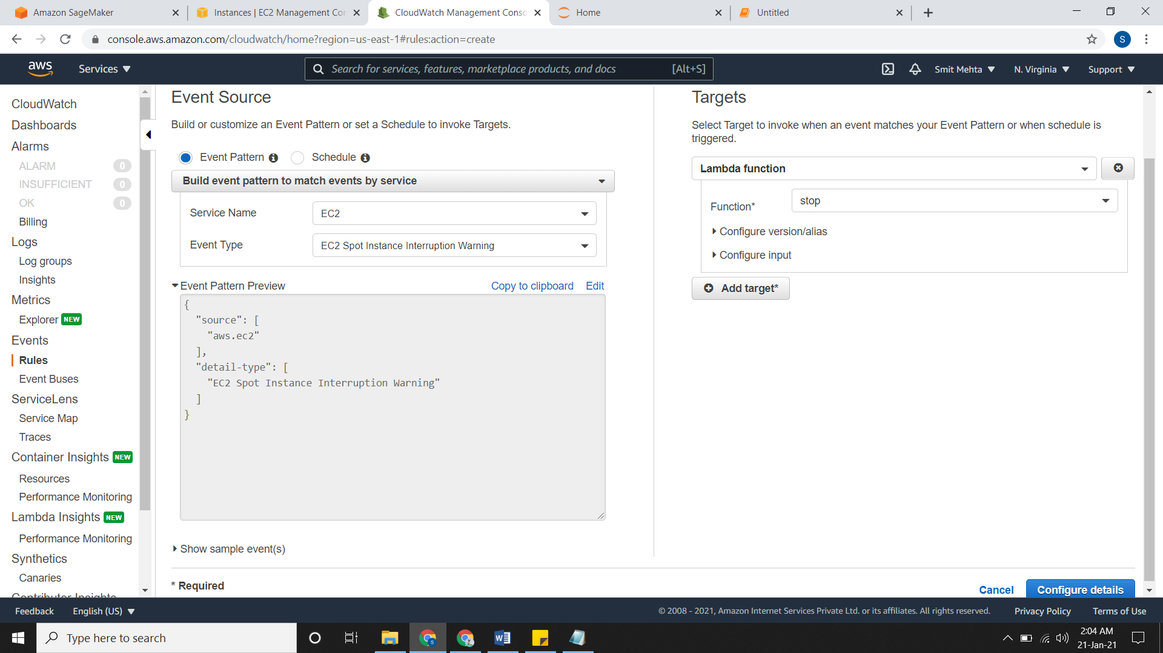

**Schedule**

* Go to **events**, click on **schedule** and select the pattern as you want:

1. **Fixed rate of:** It is a fixed/particular rate of time when the action will be performed like 5/10/12/anytime minutes/hours/days
2. **Cron Expression:** It gives an exact time when you want that action to be performed. Syntax is Minutes Hours Day-of-month Month Day-of-week Year

* If you have entered the proper cron expression, then it will show you some sample timings.
* Under **targets** select the **Target function** and then select the function.
* Select the **Configure version/alias and input** accordingly and if not it gets selected by default.
* You can add many targets by clicking on **add targets,** select it, review it and **create rule**

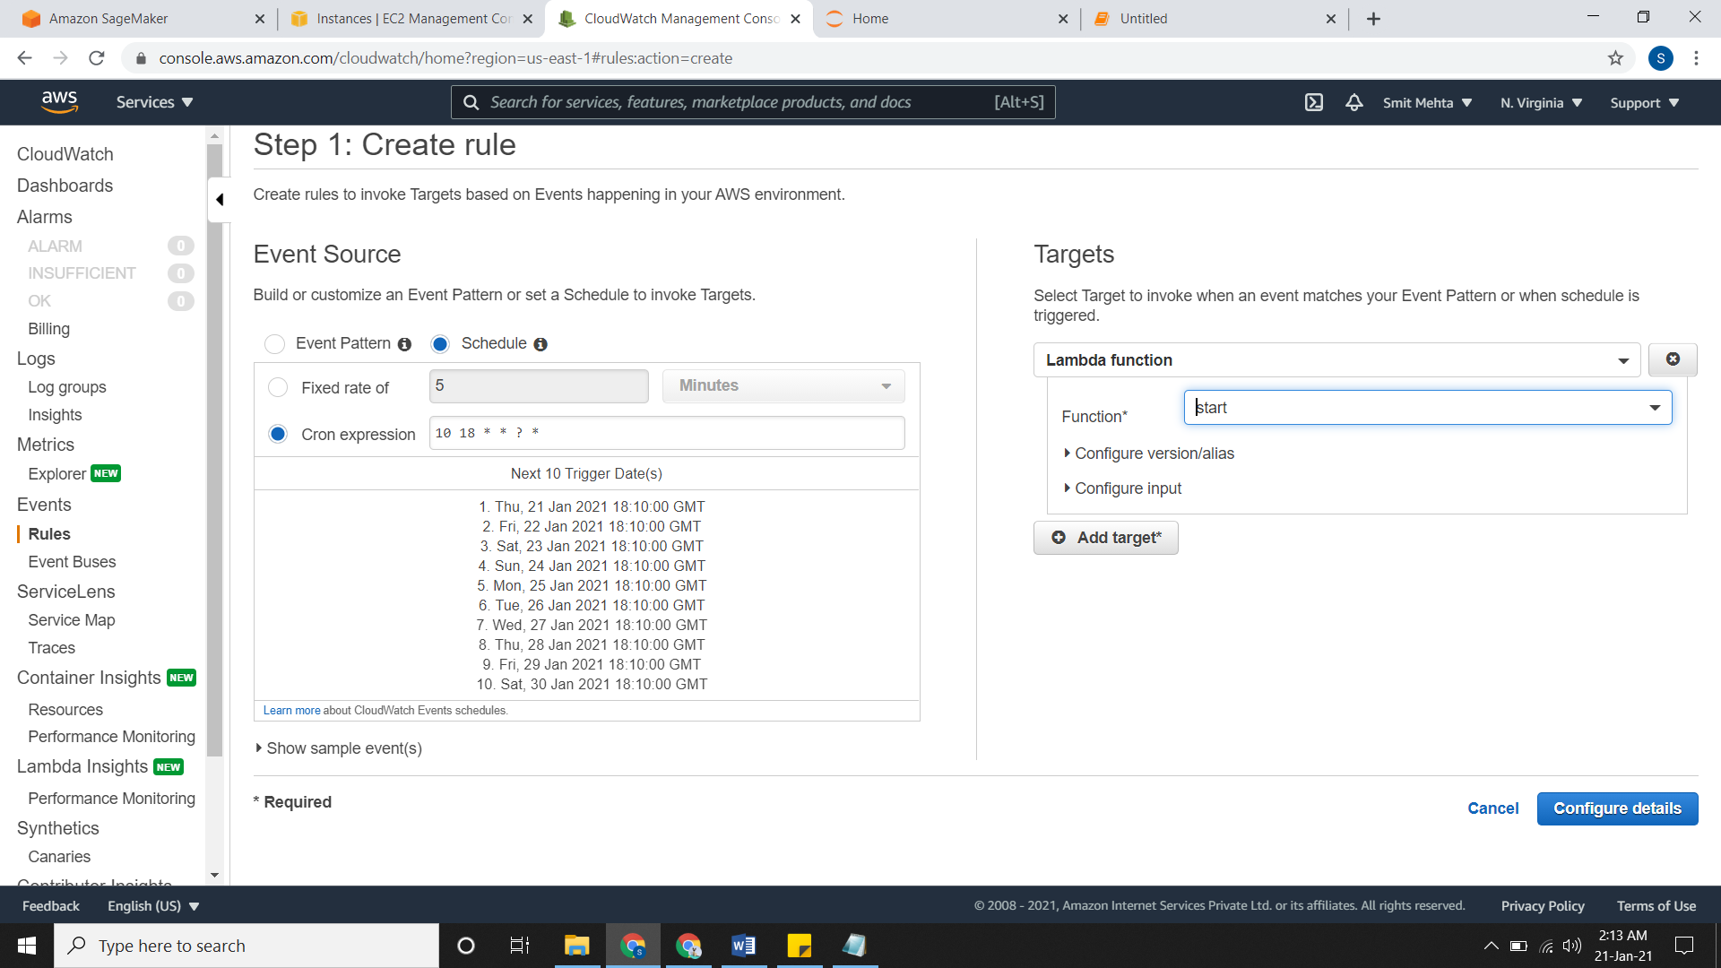

* Similarly, you can create a role for **stopping** the instance

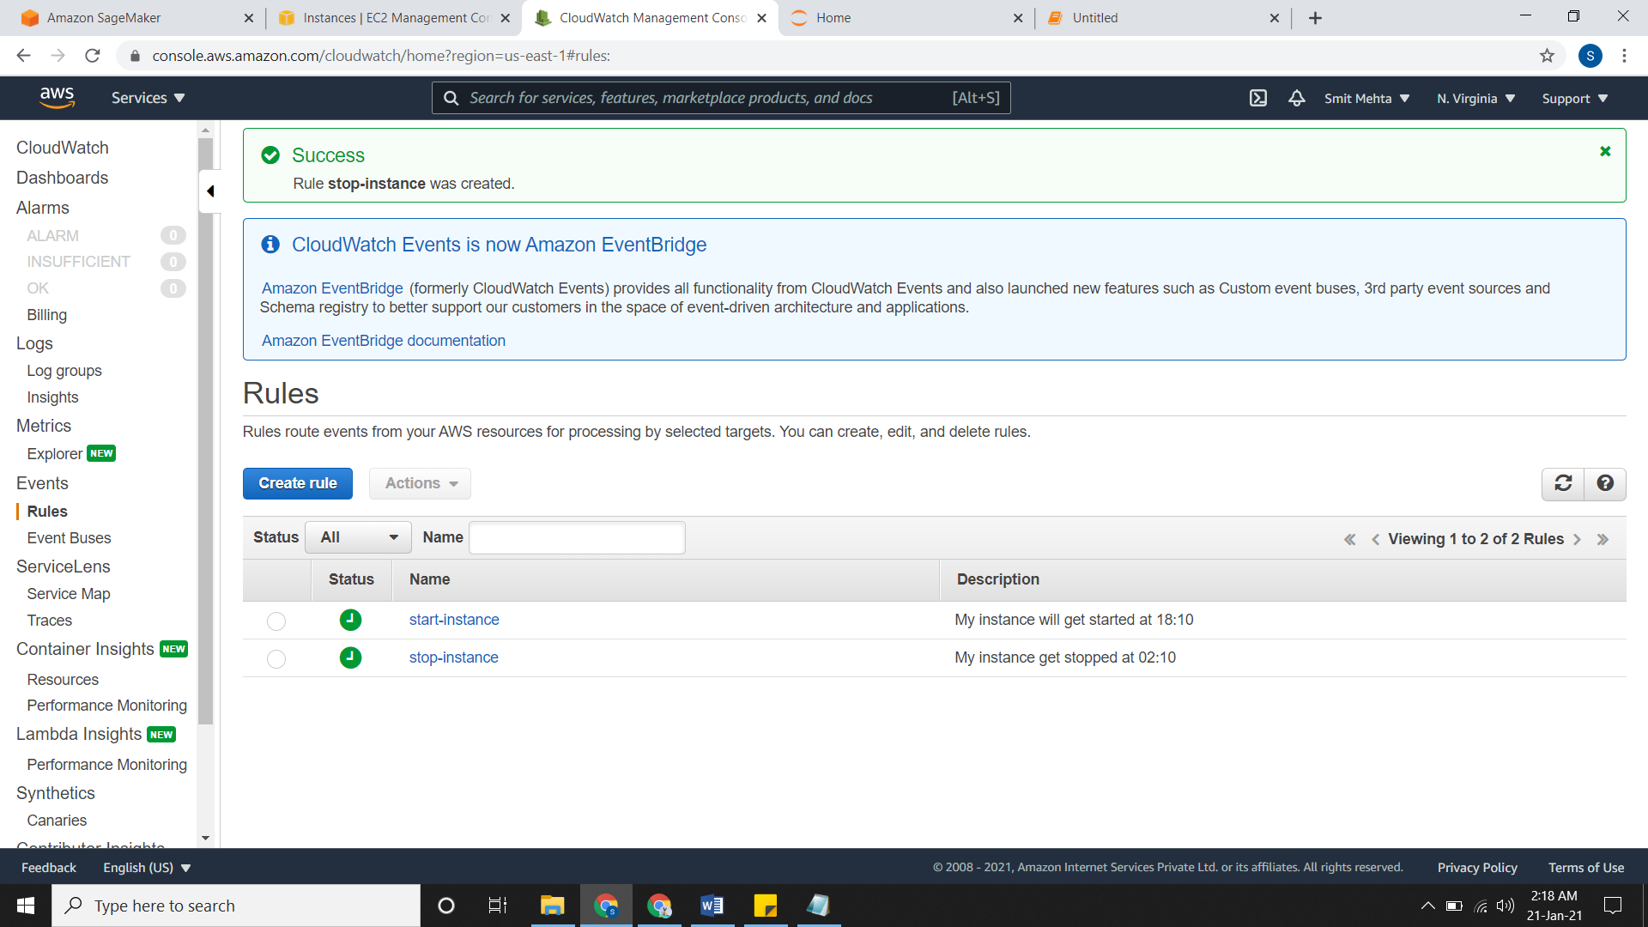

* Now your instance will automatically start & stop at their respective timings.

**CLOUDWATCH LOGS**

* Log files are detailed record of events that are curved when you are using in AWS environment.
* Your system also has log files and can be seen in an application called **event viewer.**

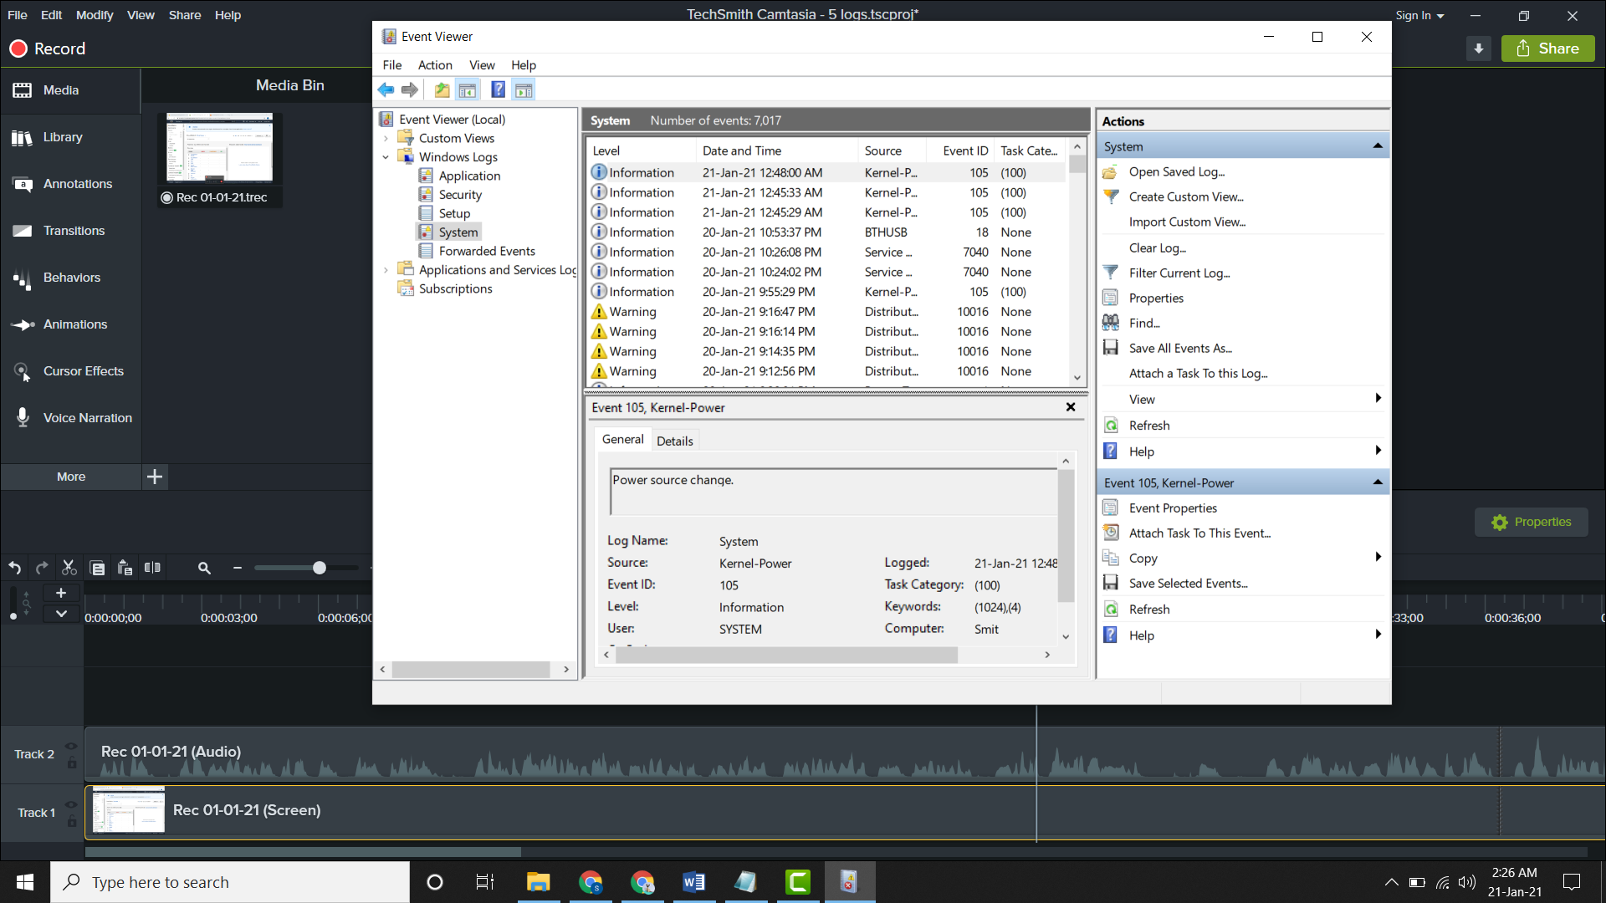

**Creating logs:**

* Go to cloudwatch, click on **logs**, click on **view log groups** and from here you can view and create logs.
* Click on **create log group,** give a **name,** in **retention setting** select it as your choice that when will this log group gets expire.
* Under the **KMS key ARN** type the KMS ARN; if not then its optional and then **create it.**

